**POWERAPPS**

**Features**: Easy to use

Run it everywhere

Connect to anything

Customized

**Why learn PowerApps**: Create impact fast/increase productivity

Get hired

Improve your toolkit

Power apps have 3 elements -> Canvas

Model Driven

Sharepoint

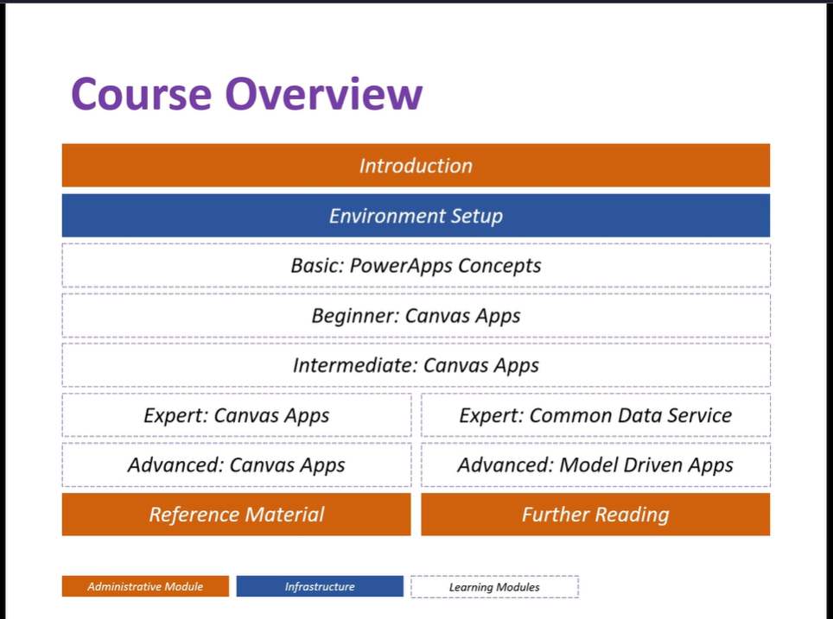

If you don’t have “Work email” use [Temp Mail - Temporary Email](https://tempail.com/en/) link. This link will generate some temporary emails and inbox for that mail.

Open power apps sign up page. Sign up using organization mail.

Login for free using tempail data.

**Basic Canvas App**

**Start from data**:

Using Onedrive account: Sign in to onedrive -> Download excel(excel data which we want to use) -> Go to onedrive -> right click-> new -> excel workbook -> Copy (downloaded)excel data and paste in excel workbook -> Select data go home format it as table -> Do necessary changes in data you want

Go to PowerApps -> now we need to link one drive with our power apps account -> Connections -> new -> select onedrive -> Select Create-> Enter onedrive credentials -> Navigate to created excel path in onedrive -> select excel name -> click connect -> It will create our 1st app.

**Connecting data to google sheet**: Google drive -> Right click -> select (New) google sheet-> Copy data from downloaded sheet data and paste in google sheet -> do necessary changes in sheet (change sheet name ) -> and save -> Go to power apps-> Start from data -> new -> connection -> New connection -> google sheets -> Enter google drive (mail)credentials -> Open mail(google drive mail in connection)-> find sheet path -> click on connect

It will open sheet structure like table refresh button in power apps screen ->Click on Preview-> code will run Click on Refresh button if it’s not running stop execution-> check red mark/error-> google excel sheet is opened close it and run the code again (Click on Preview) -> refresh it -> it will show data.

**Steps**

Open google drive

Click on new -> google sheet

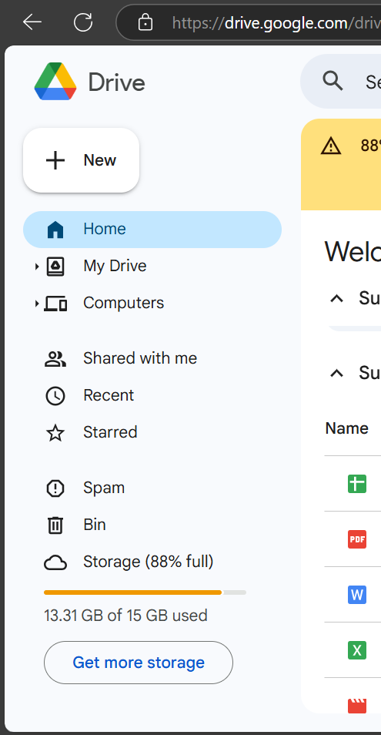

Sheet will open-> copy paste data -> rename sheet and save.

Click on create:

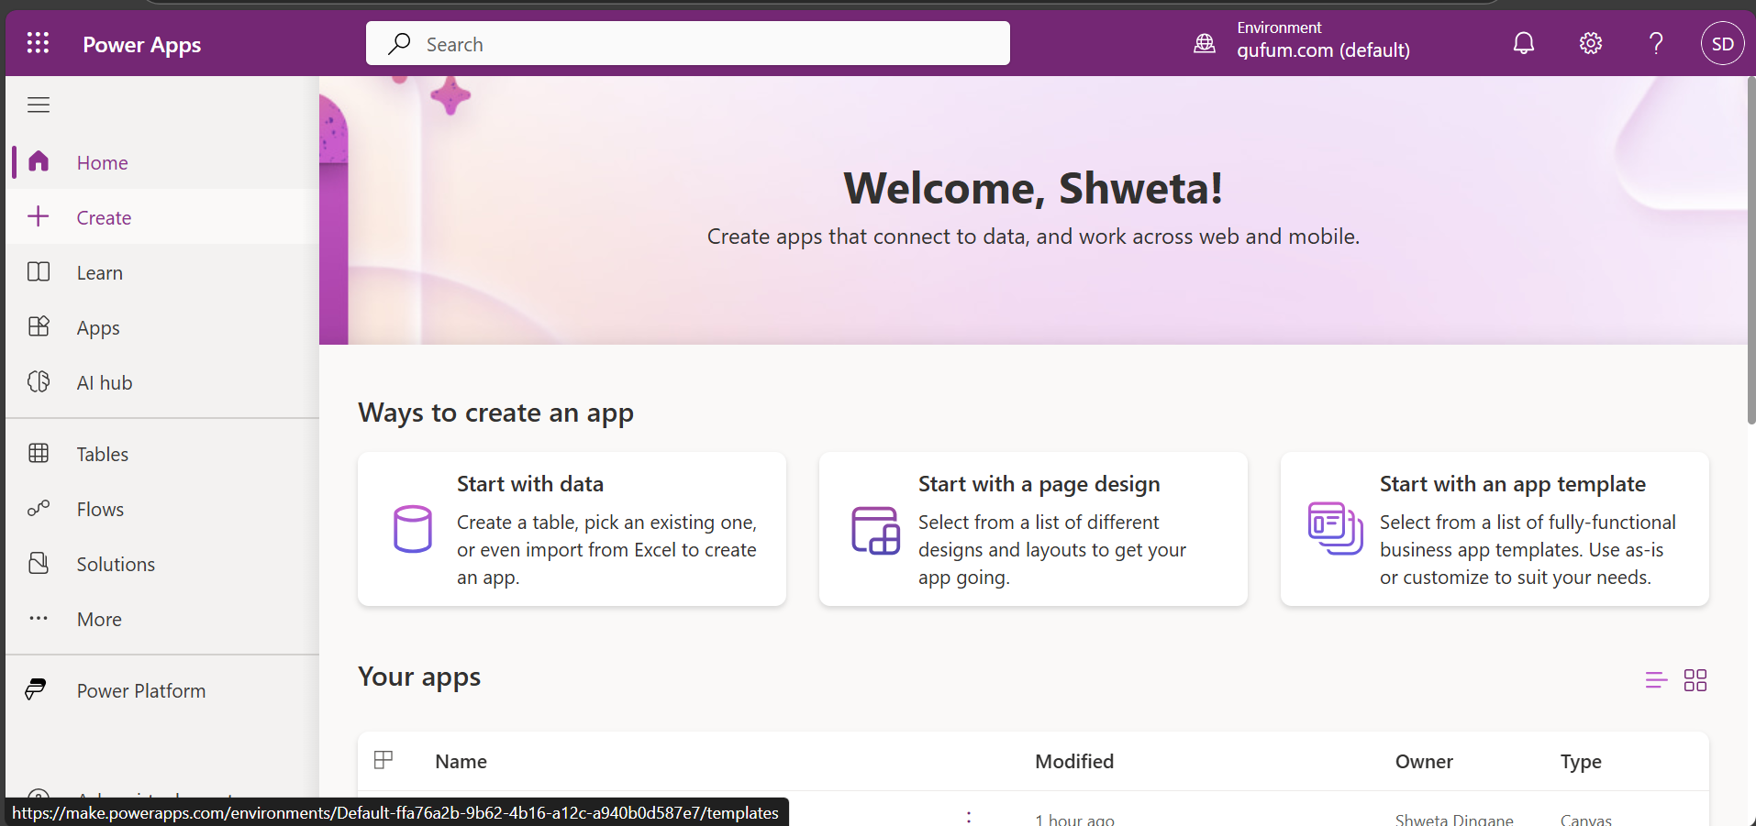

Click on excel

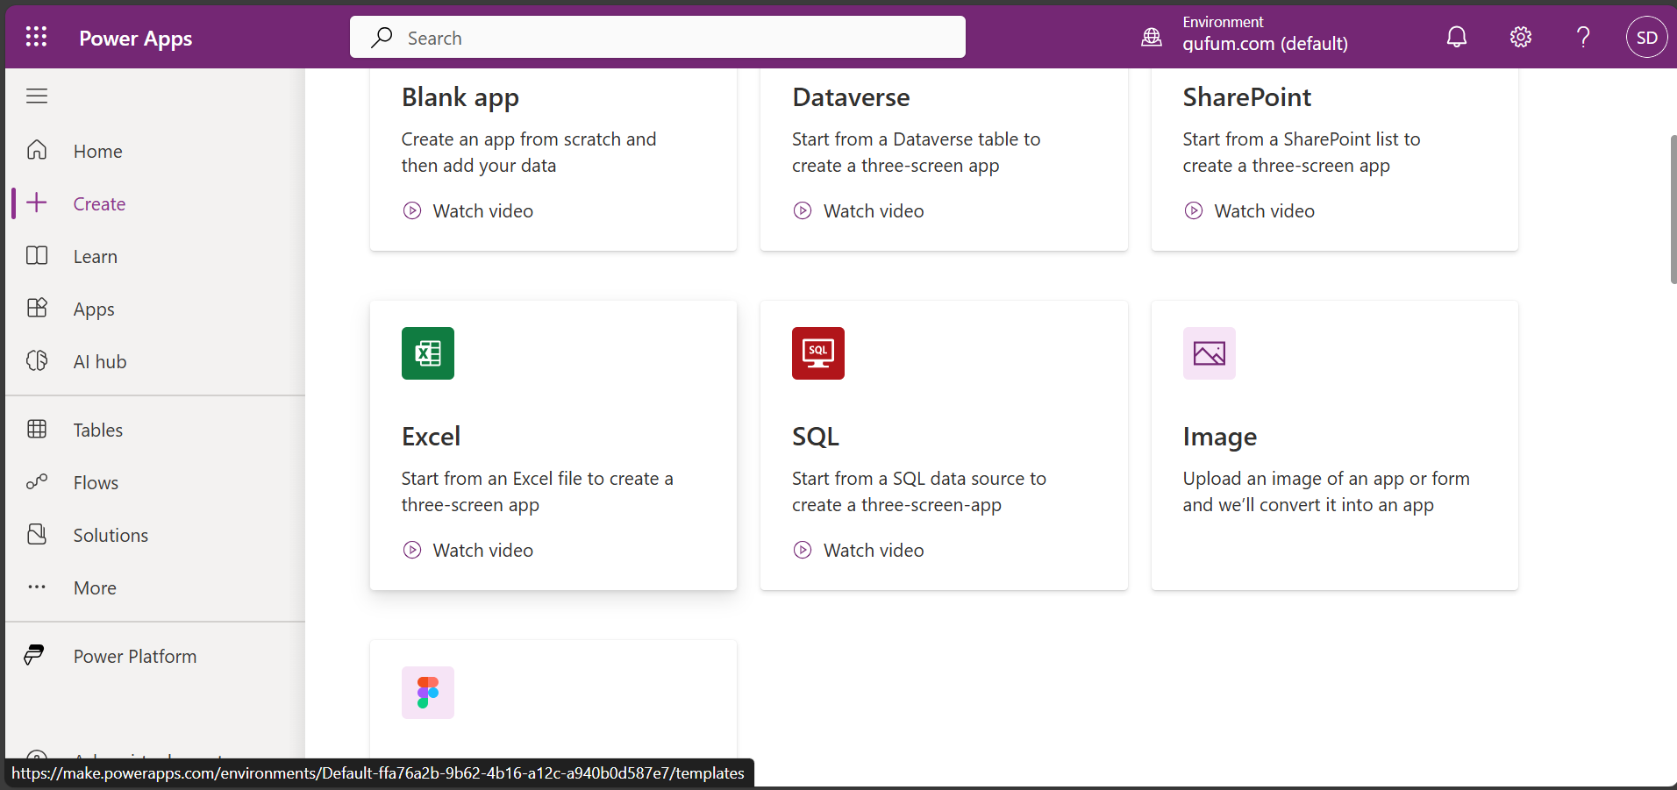

New screen (below) will open

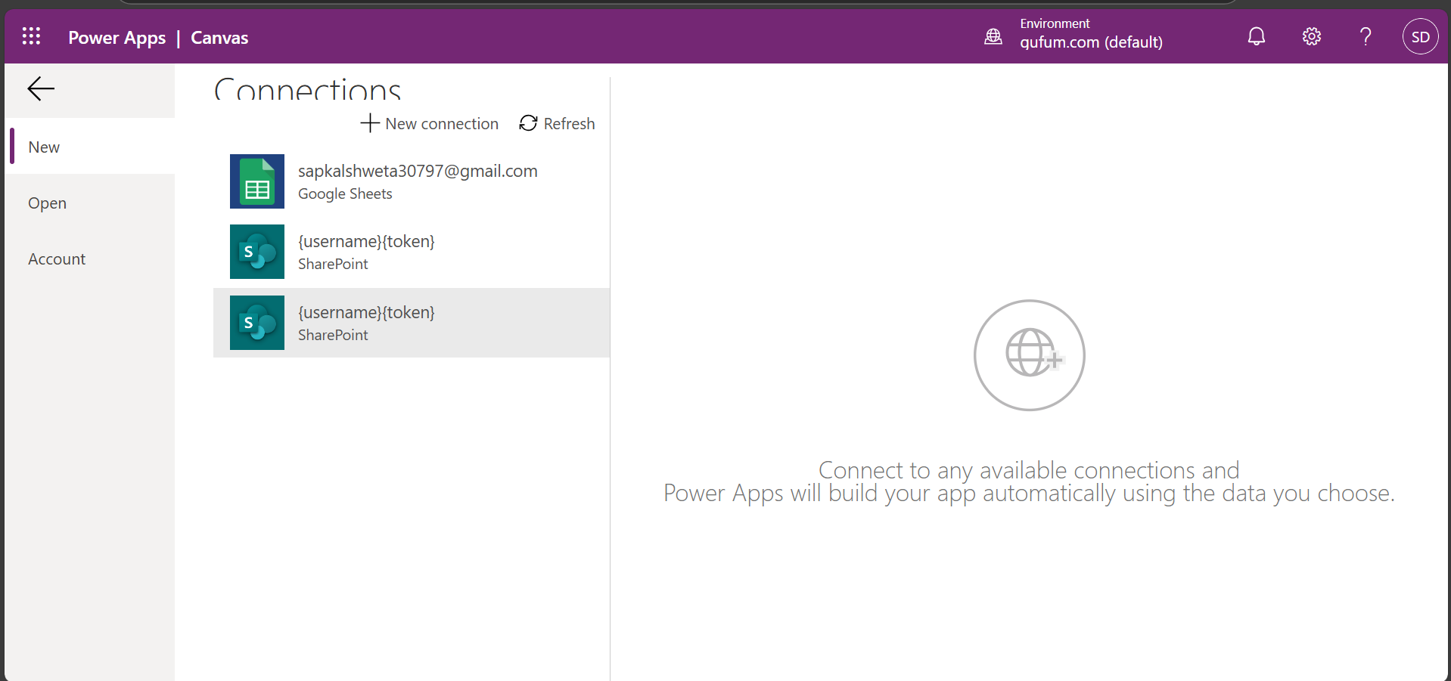

Click on new connection

Select Google sheet

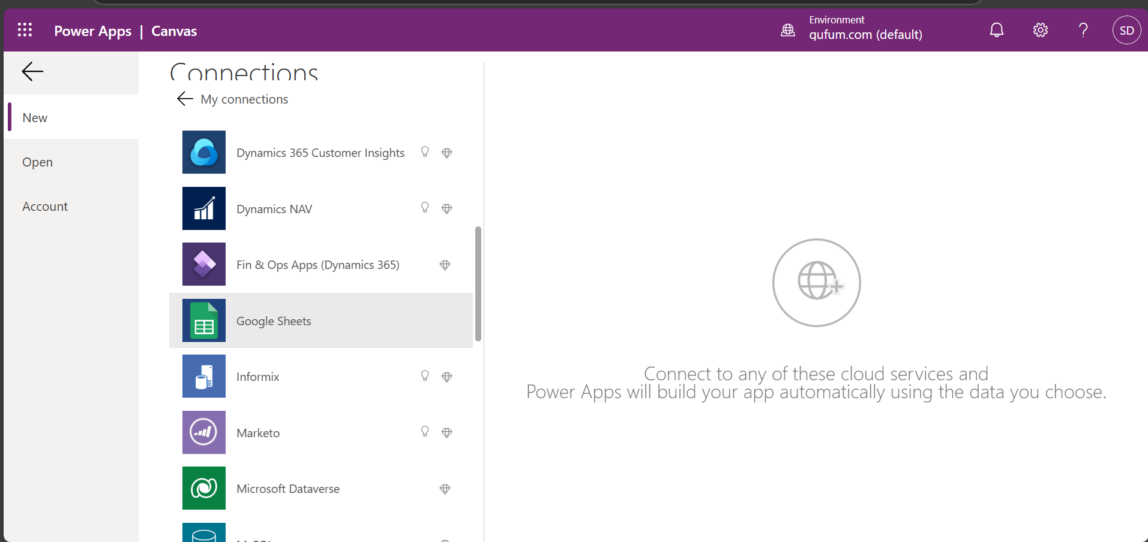

Click on create

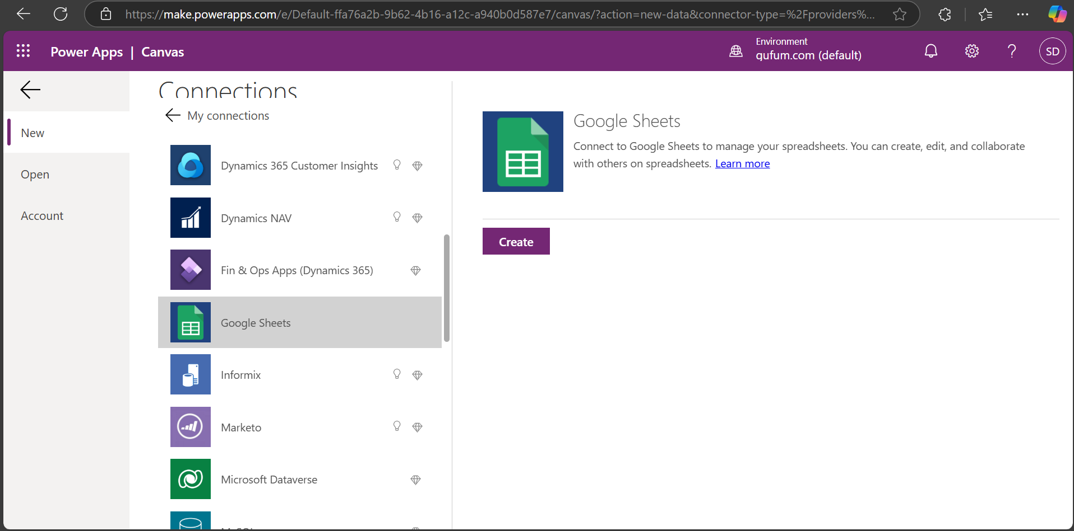

New screen will open

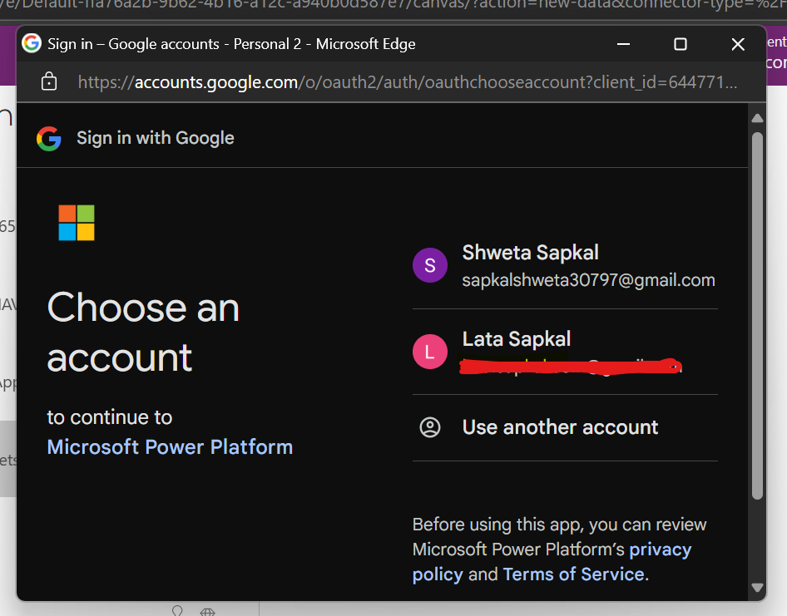

Select google drive mail and connect to google drive account

Click on continue

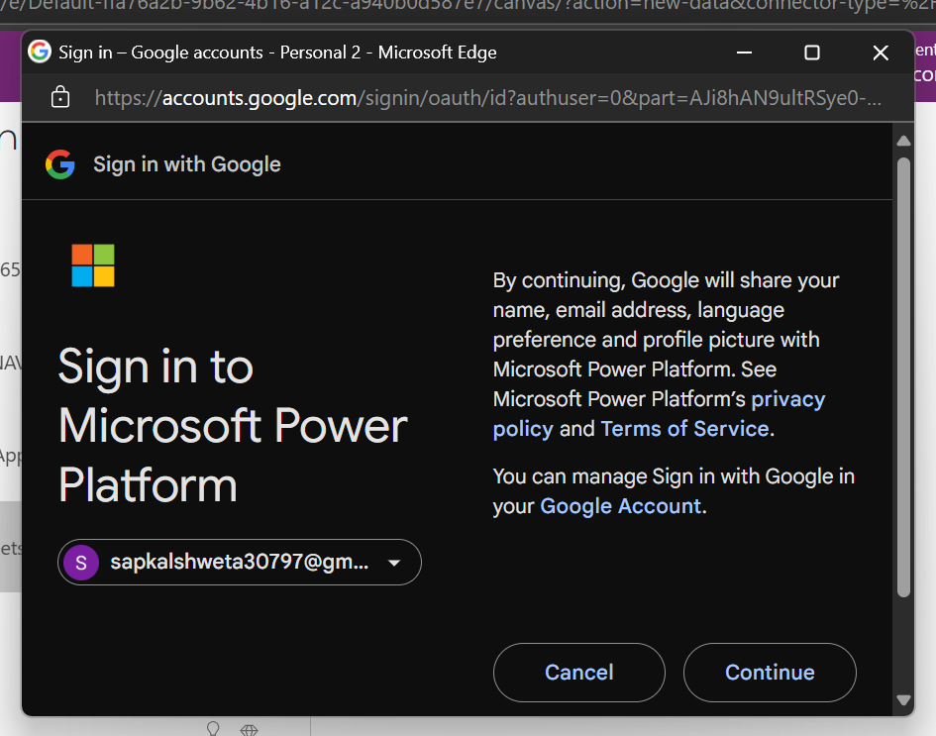

Give permission and click on continue

Click on allow access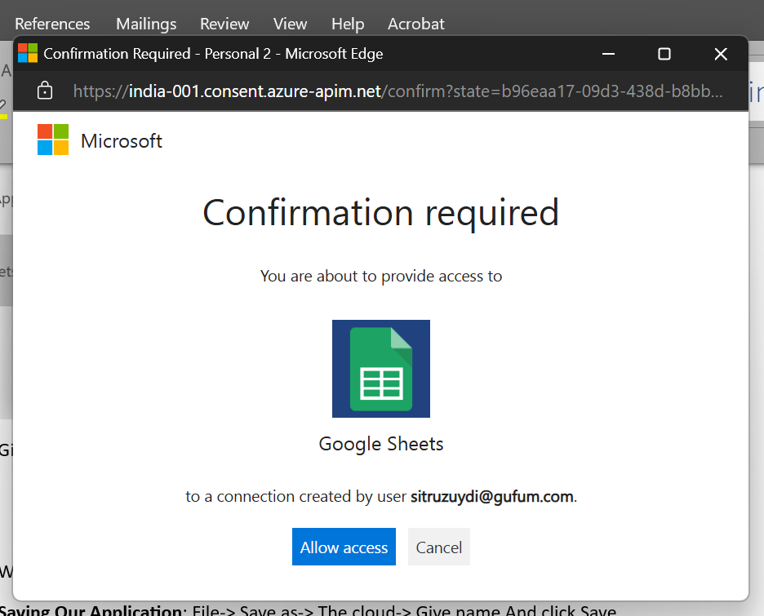

Table/screen will get open and we can see data of sheet

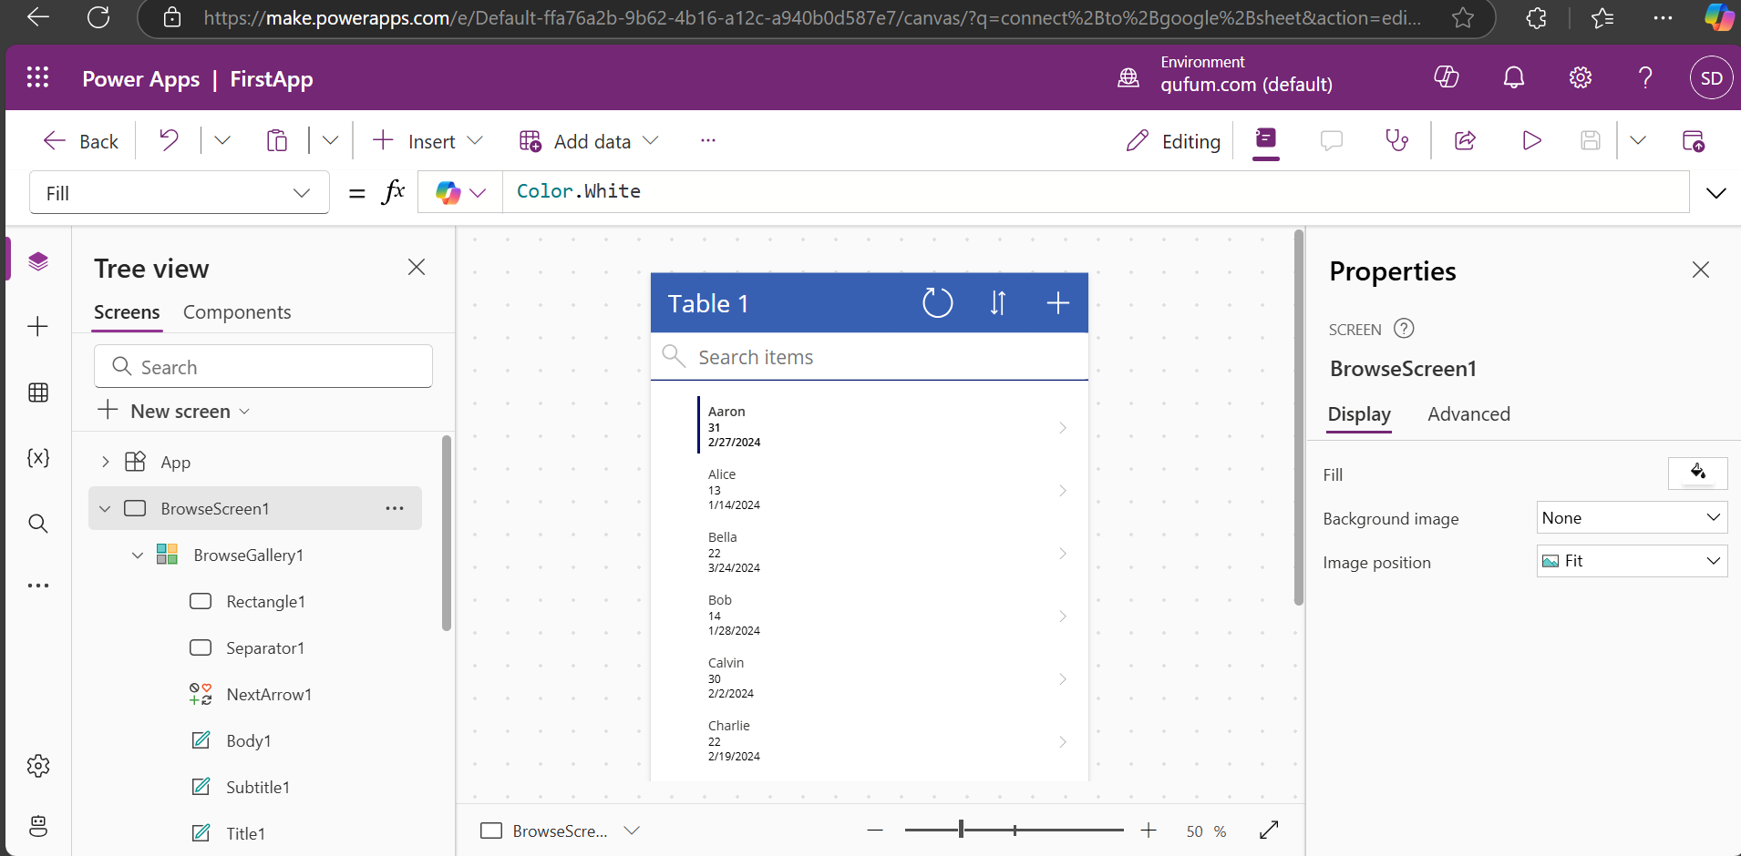

We can edit, add, delete, sort data in ascending, descending order in power apps.

Preview button to run the application.

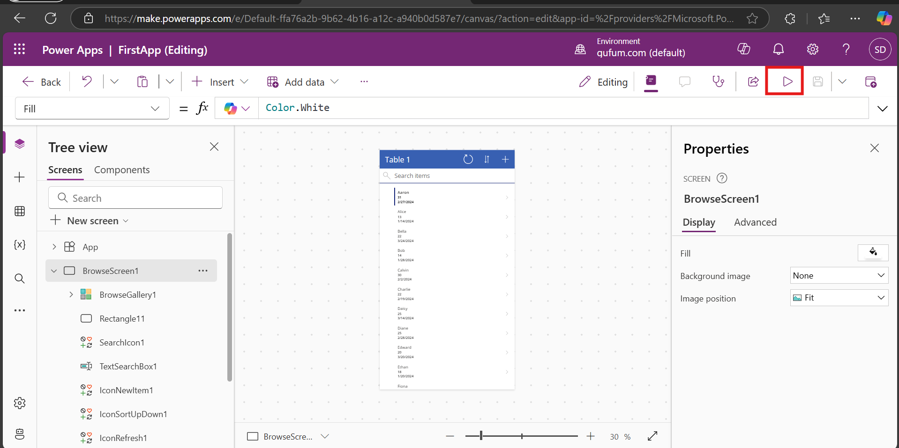

After running powerAppsId will generate in google drive sheet

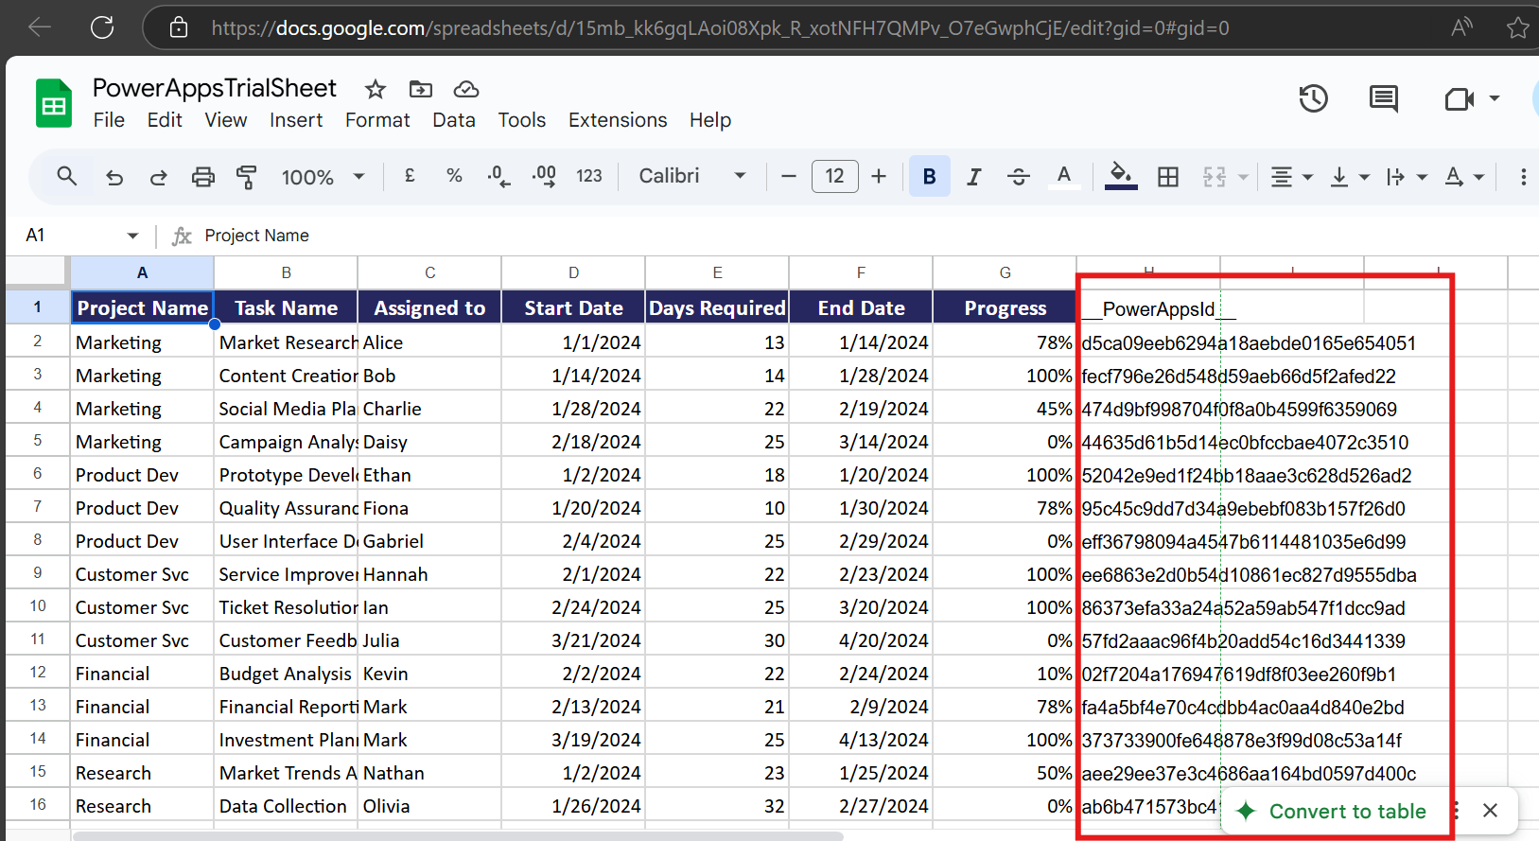

**Do not Do anything with PowerAppId column generated in sheet after creating application in power apps**

If we click on any data present in application for e.g. If I click on Aron 31 it will give me

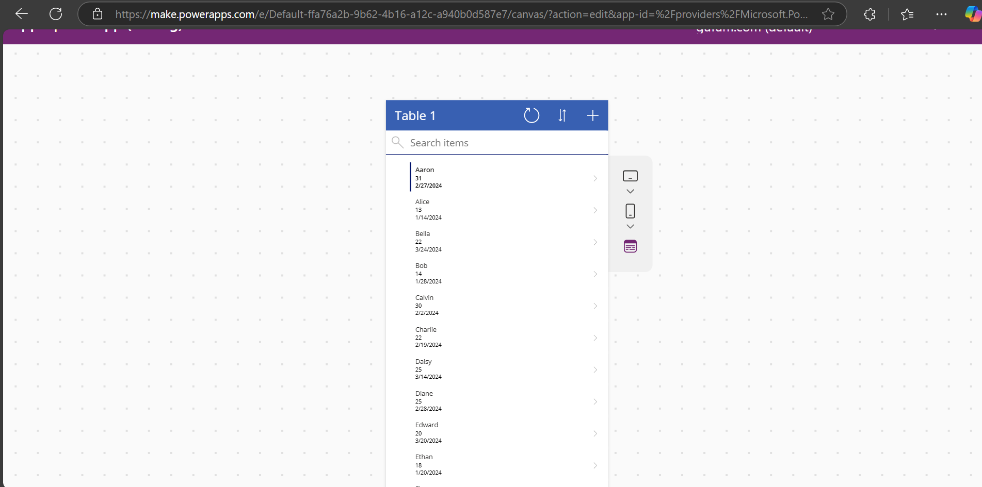

Detail screen

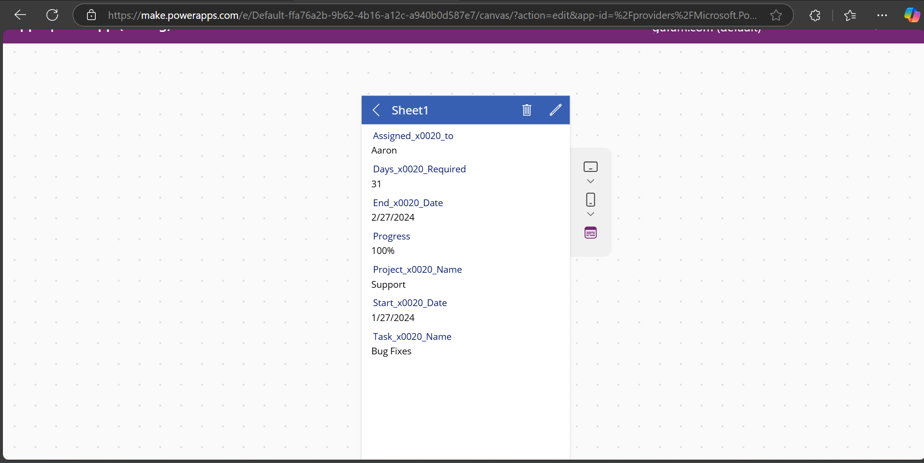

We can edit this data also by clicking on edit button

**Saving Our Application**: File-> Save as-> The cloud-> Give name And click Save.

Here I don’t have file option. Click on dropdown icon besides save button

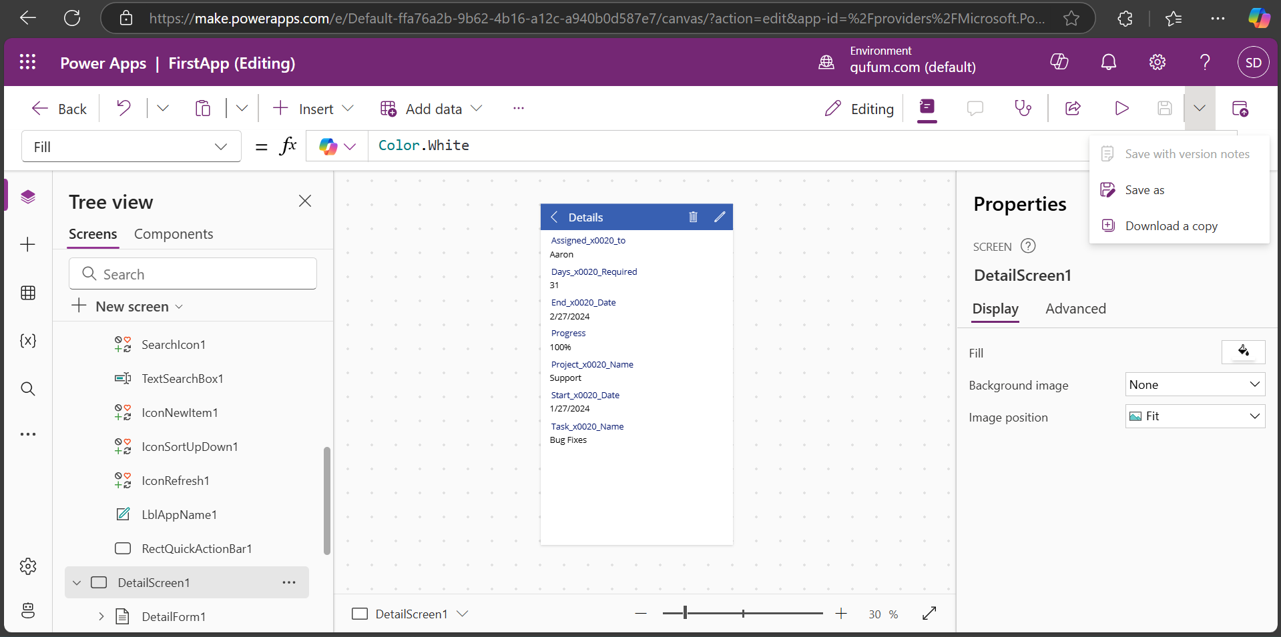

Click on Save as or Save.

I am doing changes in Alice(Assigned To column) data

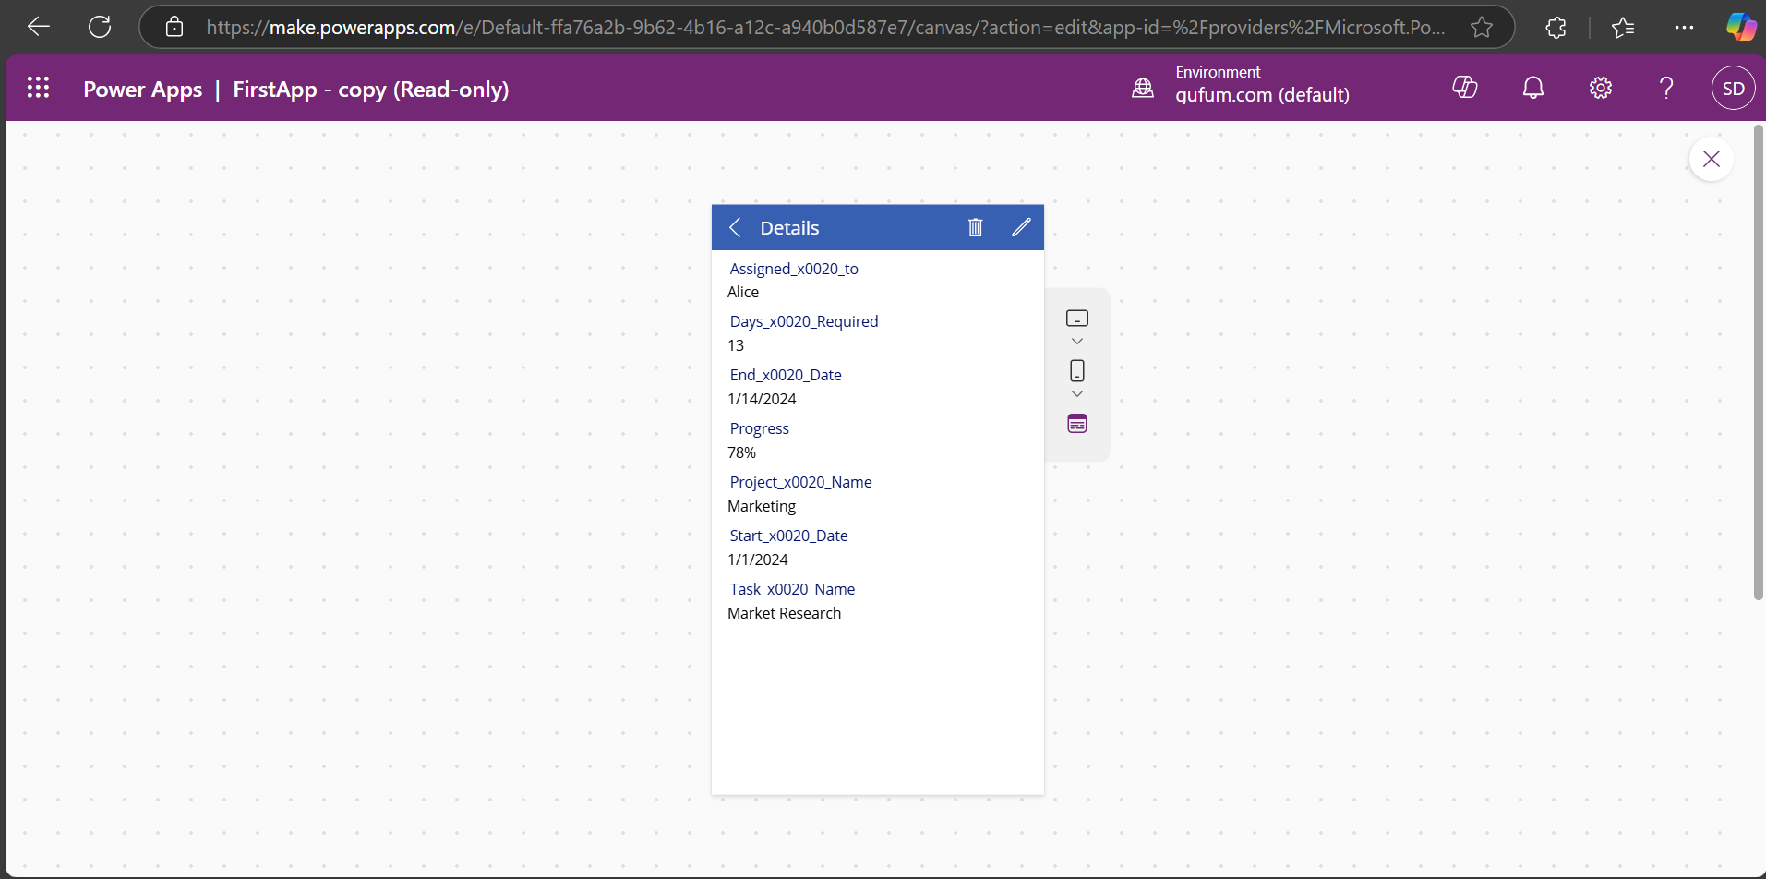

Here Progress % is 78 I will change it to 85% . Click edit button

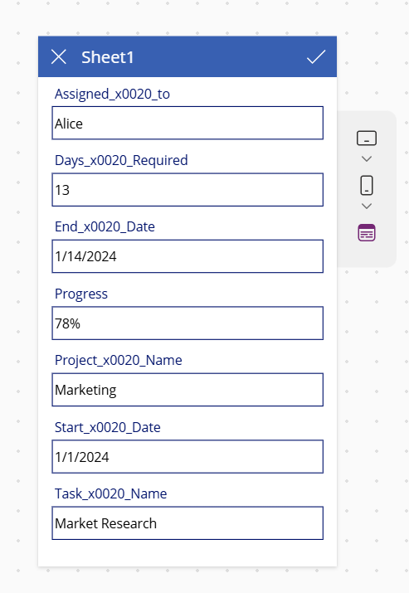

-> Change progress- >

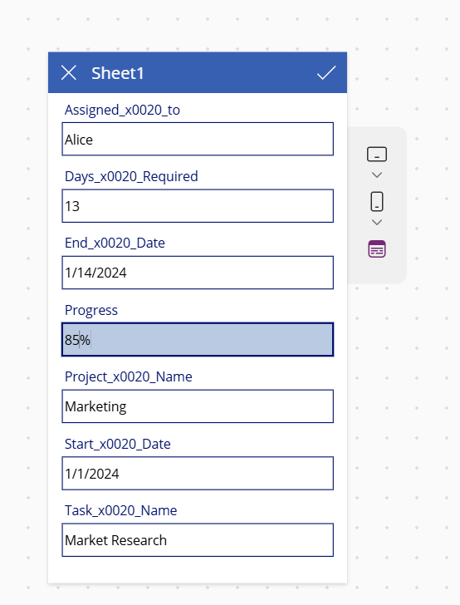

Click on

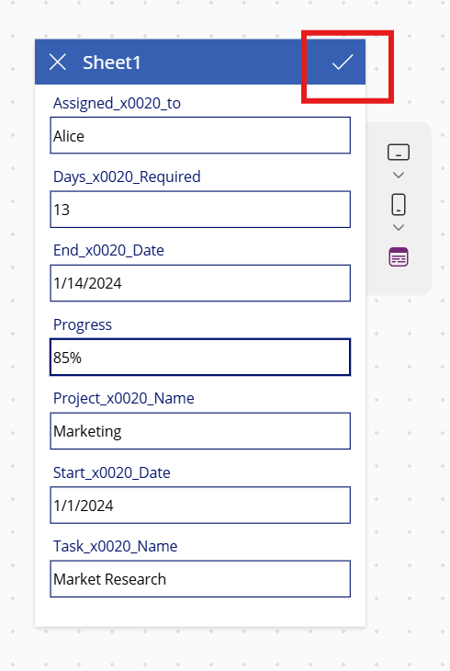

Data changed to 85%

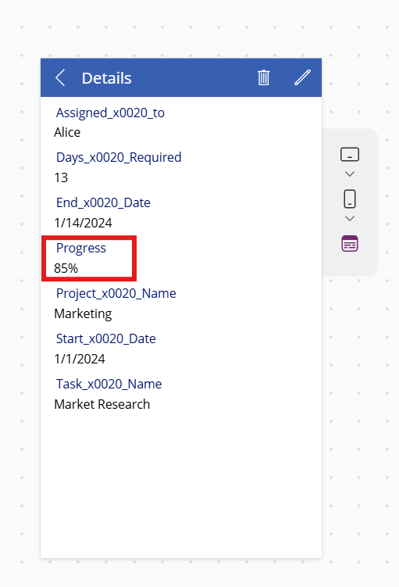

Stop the preview by clicking on x icon-> check in google sheet is changed data reflected in sheet or not.

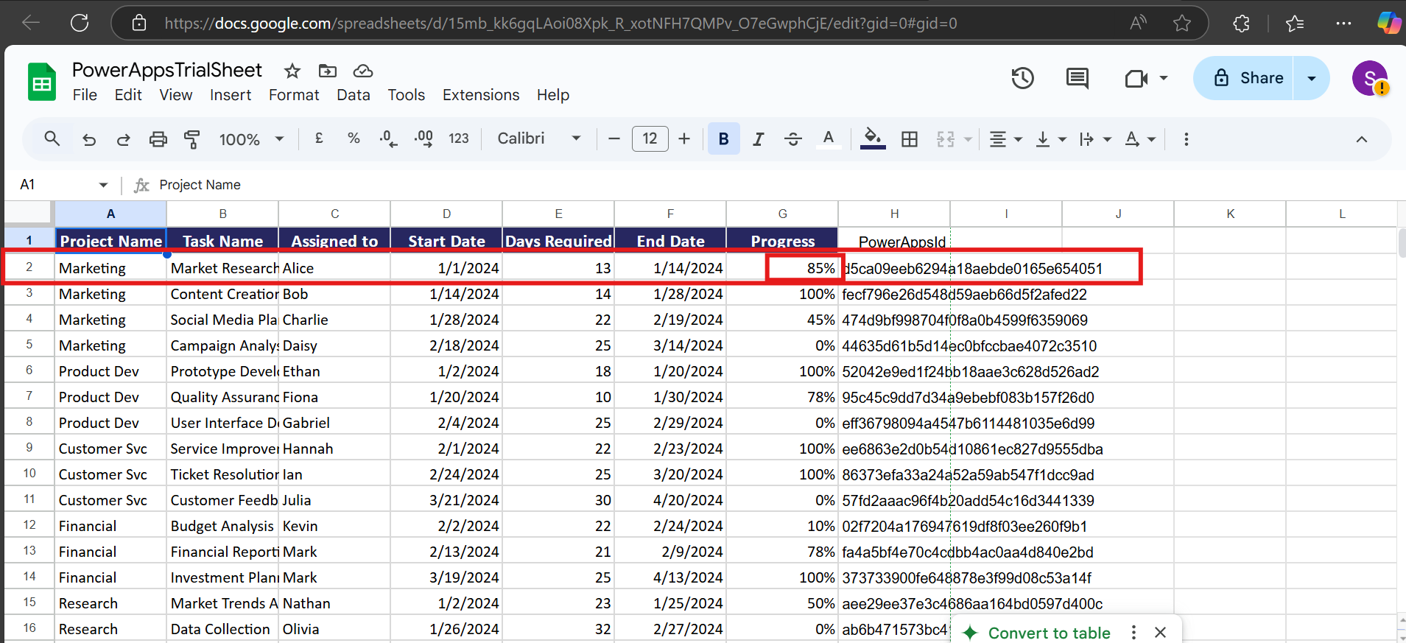

Data changed successfully.

Now I’ll add new record in sheet.

Click on + icon

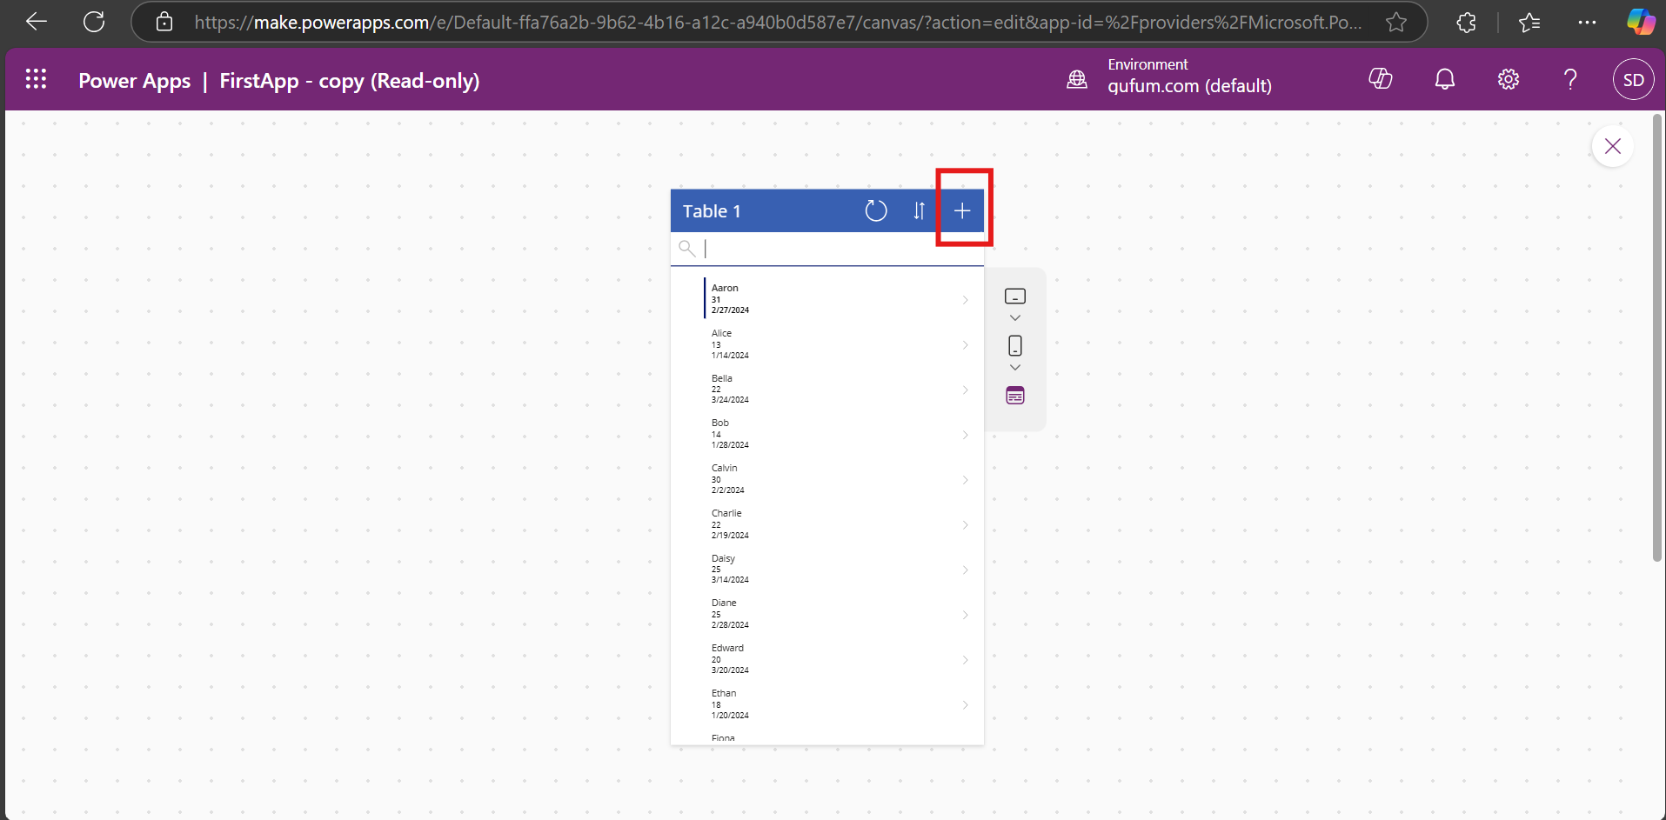

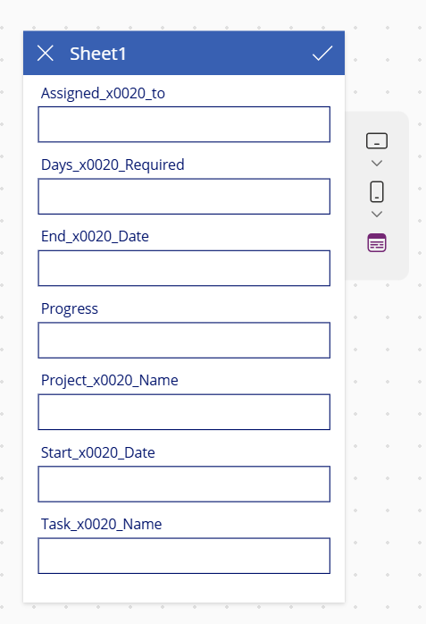

Fill the data

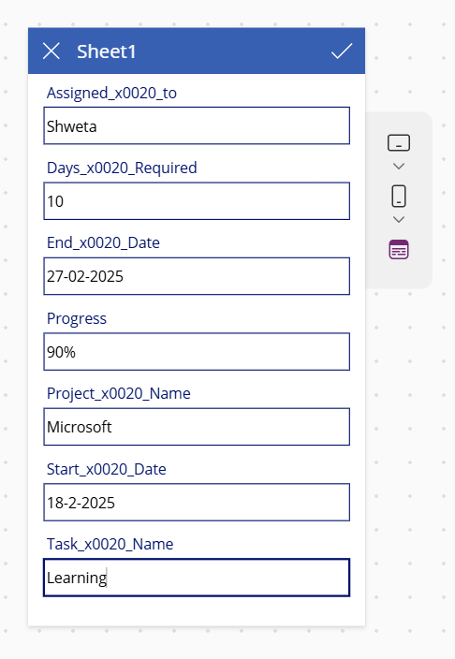

Submit item->search with name

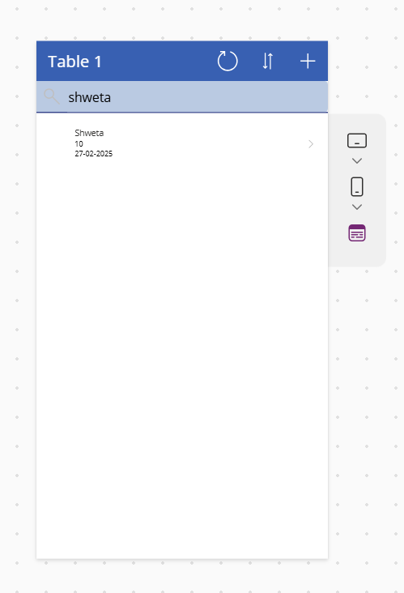

Data added successfully Also check in google sheet.

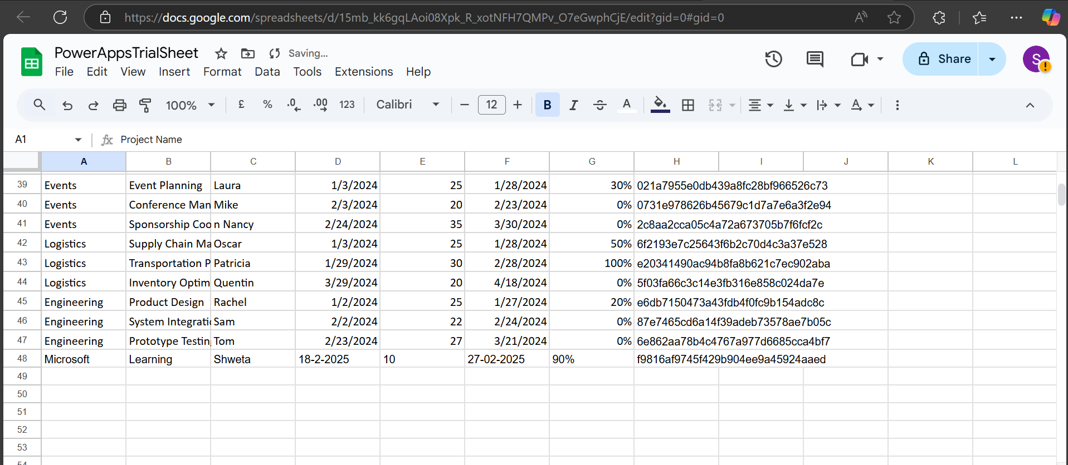

Delete a record:

There are two Fione record I’ll delete 1 fiona record who required 35 days.

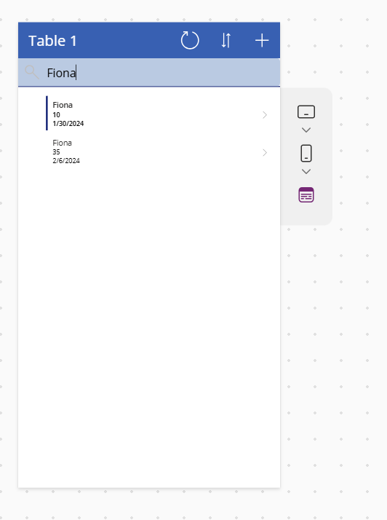

Open data of Fiona

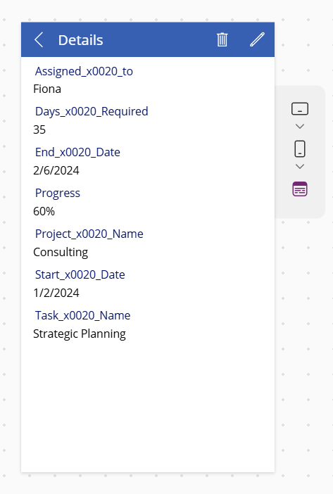

Click on delete

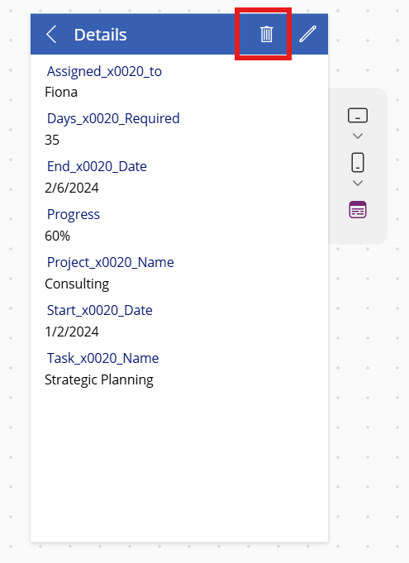

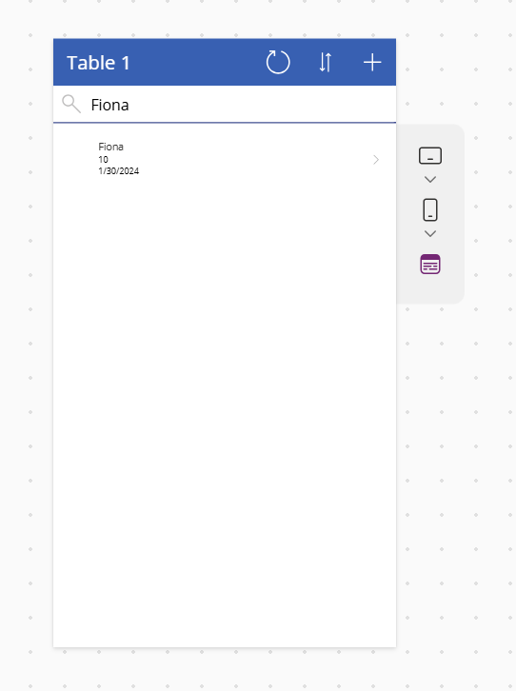

Deleted successfully. Check in google sheet also

Only 1 record is present in sheet

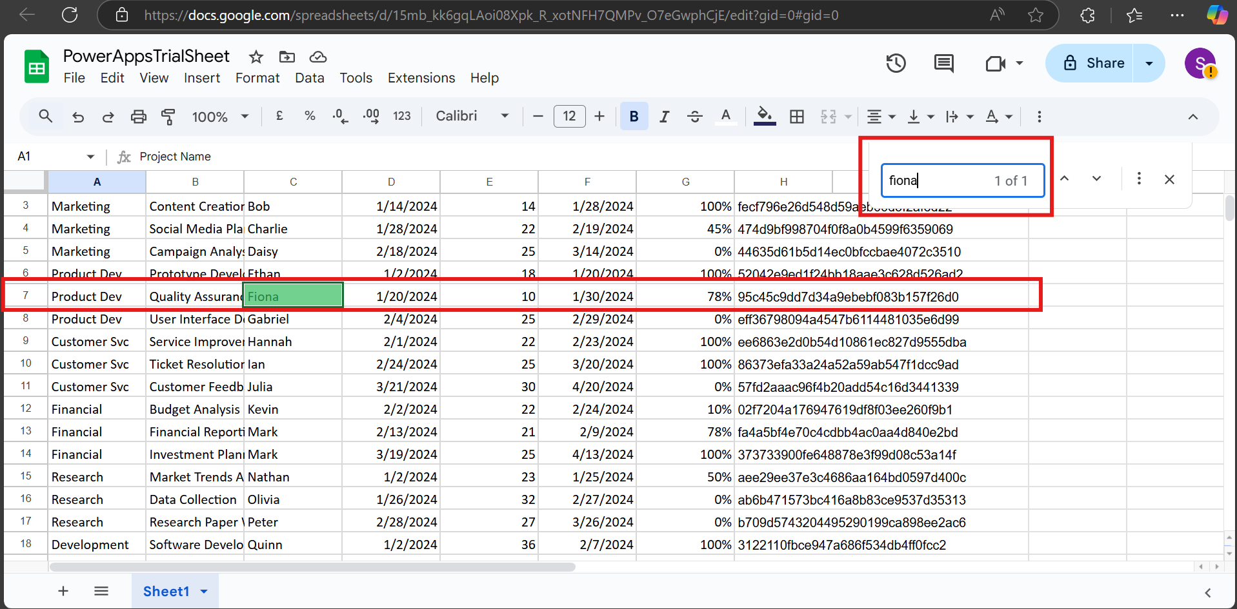

**Customizing the application**: We can add theme. Select element after selecting element we can bold it, we can change font, font size, we can apply font color also.

Use Accessibility Features

1. Tabindex=0

Select element change tabindex=-1 to tabindex=0

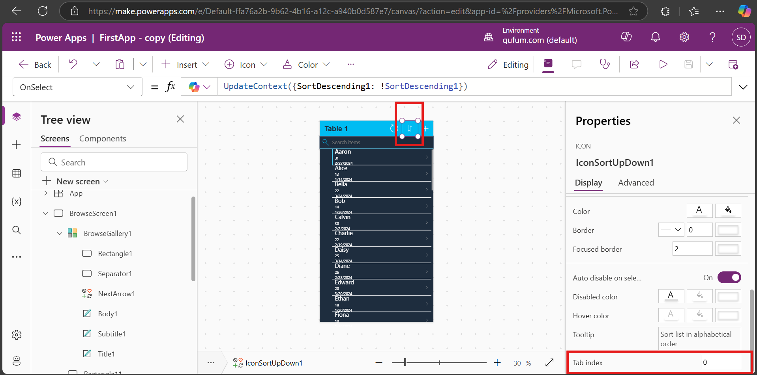

1. Adjust focused border

Here focused border color is light light to change it to black first select border color and select black color

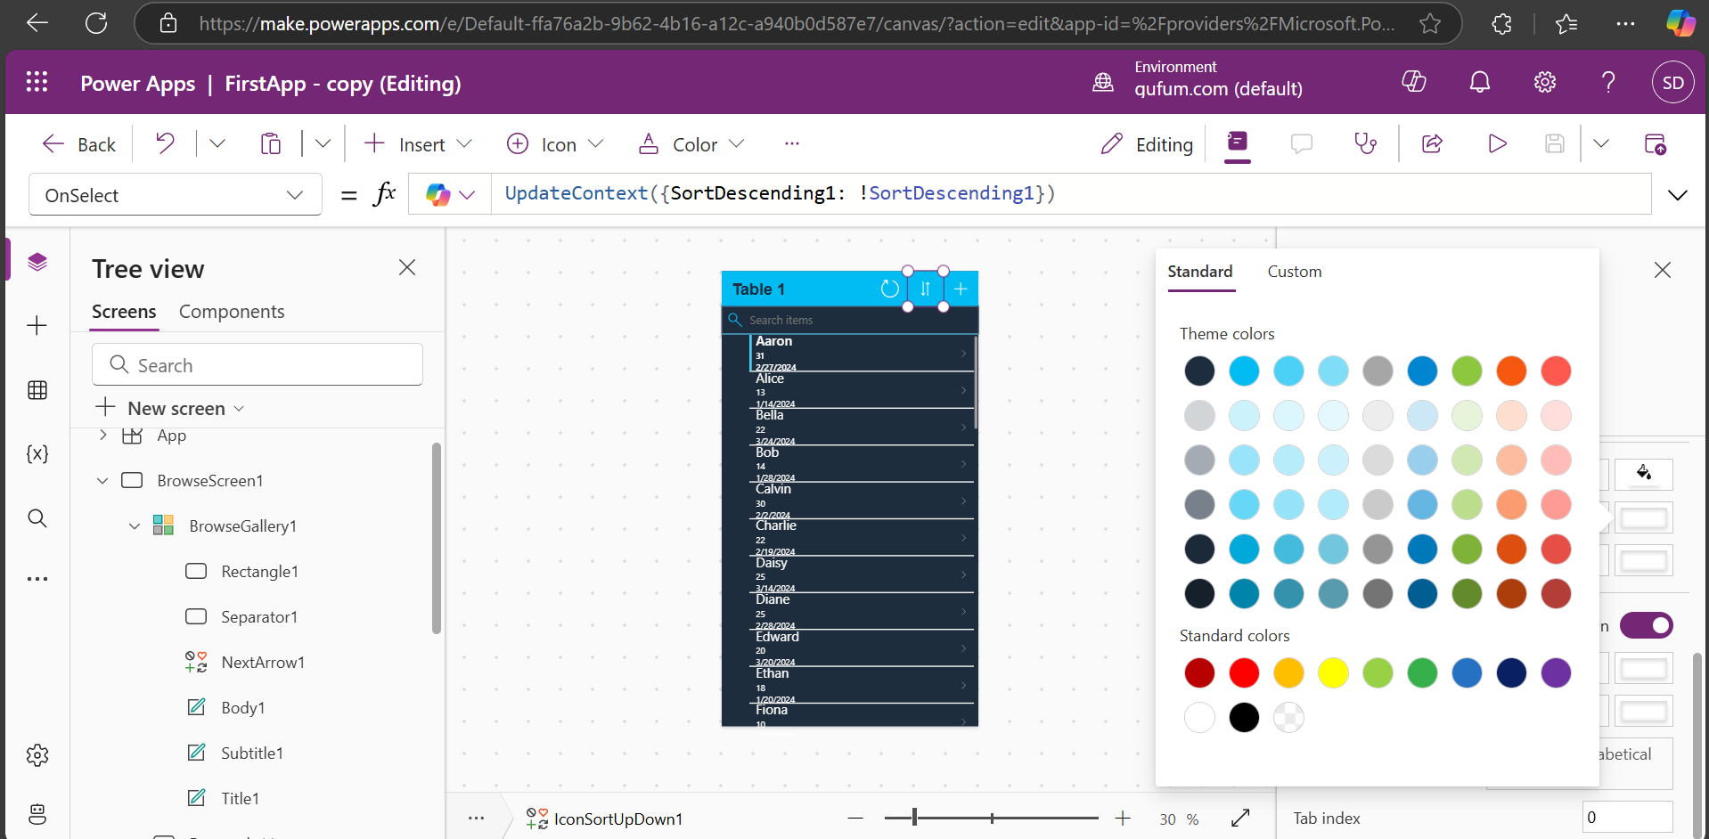

All color changed to black

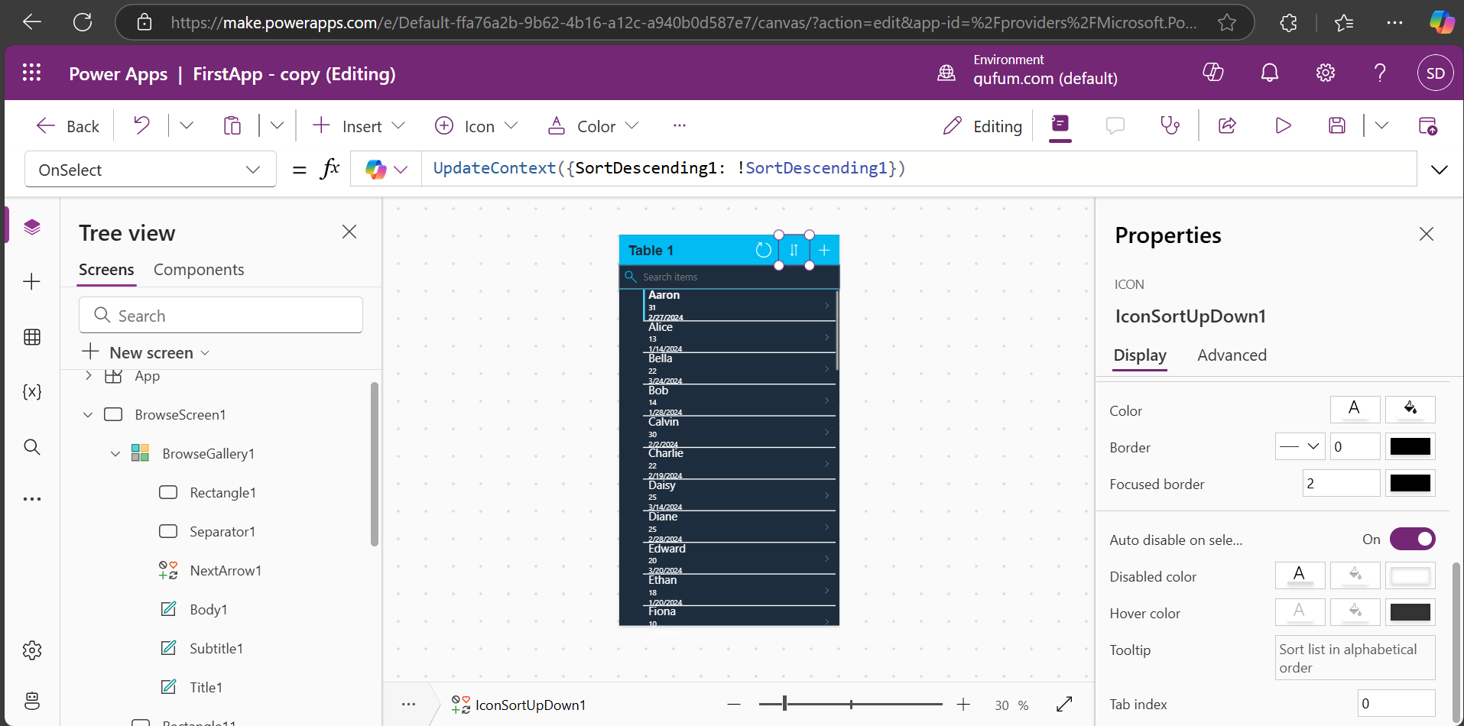

Add focused border width to 2

Run application and check

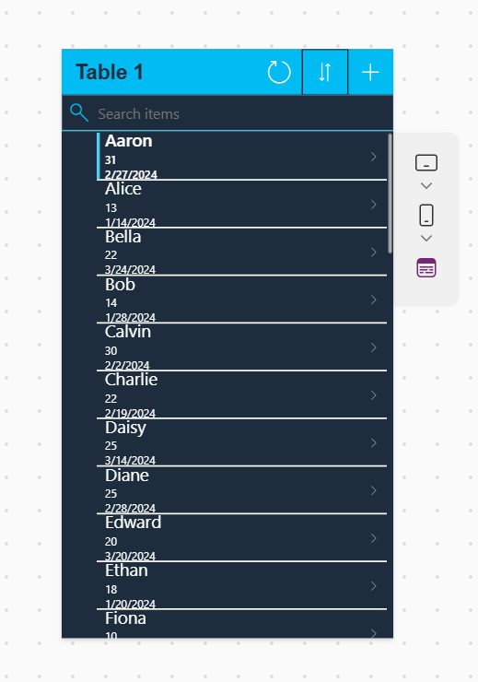

Do same for all elements.

We can customize file icon, change file name also. Goto File -> settings- >Name, Icon, background color is there we can change it. Screen size orientation also we can change.

Go to Settings->

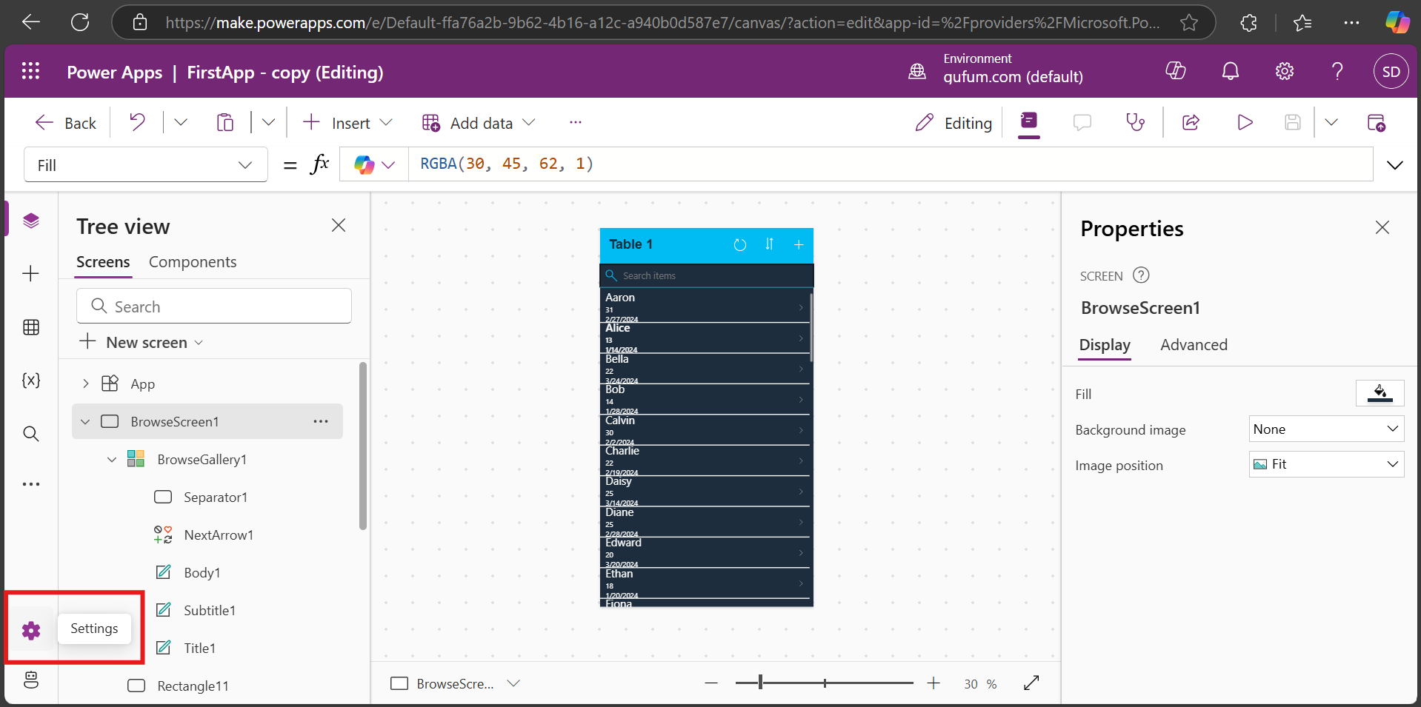

Below screen will get open

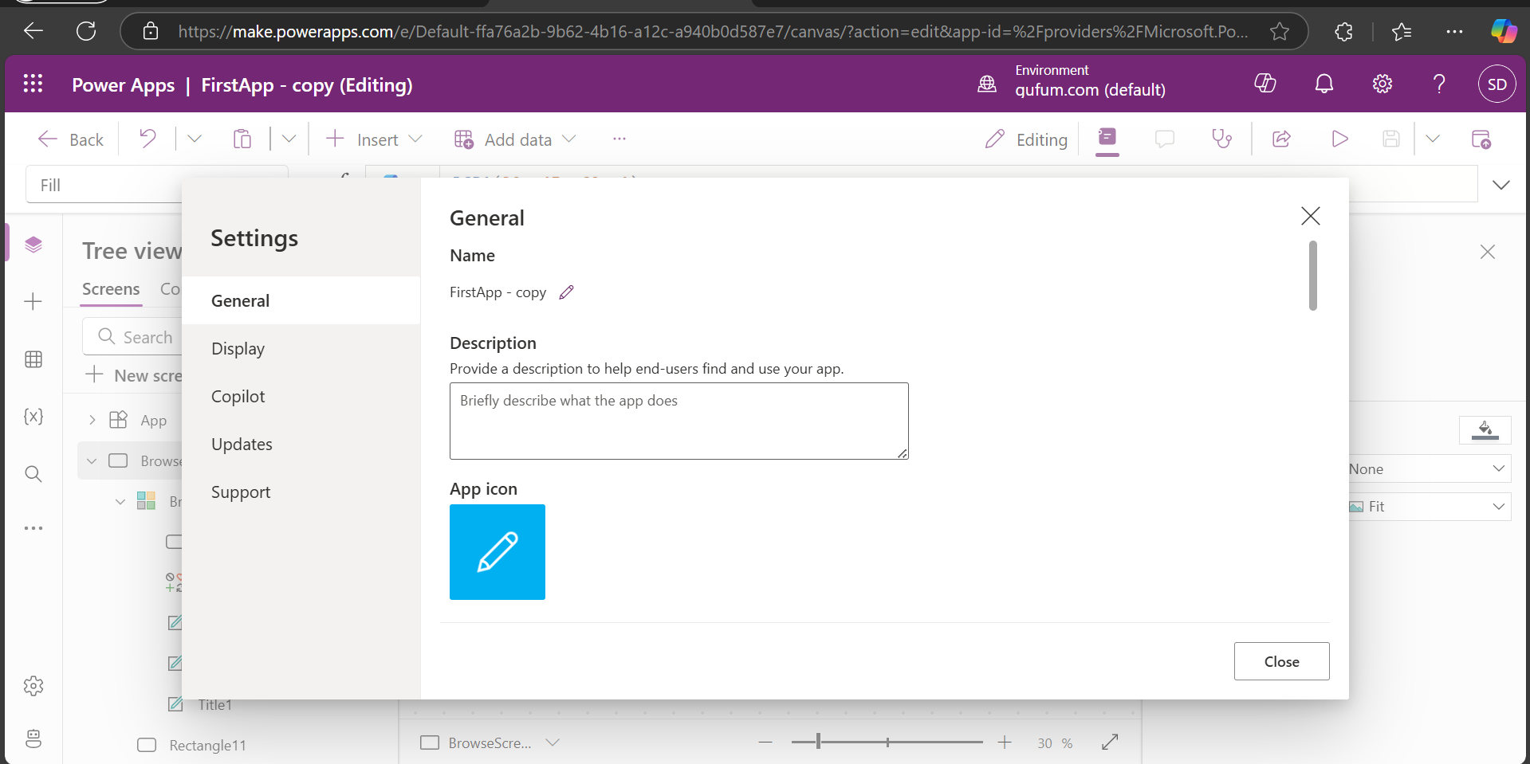

If you want to change application name you can change

I changed icon details

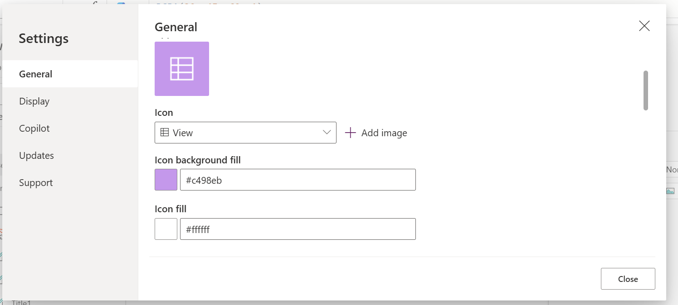

Also changed app name, added description

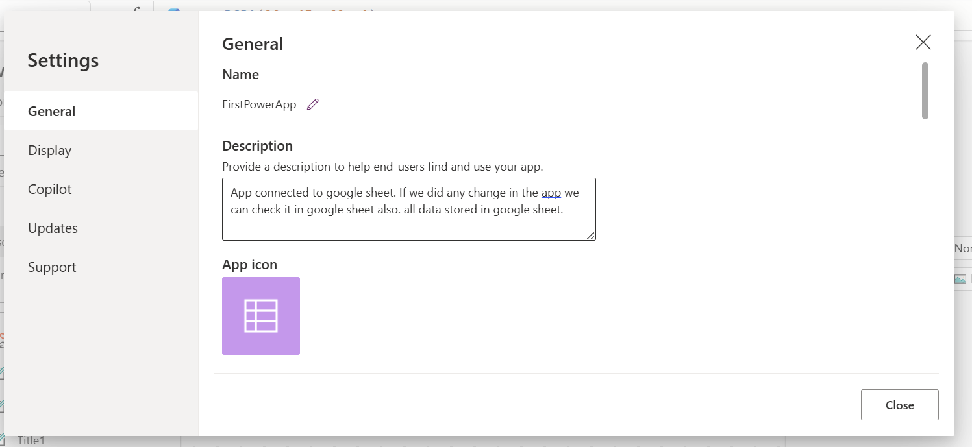

**Tree View**: which shows all of the screens of the applications

1. Browse screen
2. Details screen
3. Edit screen

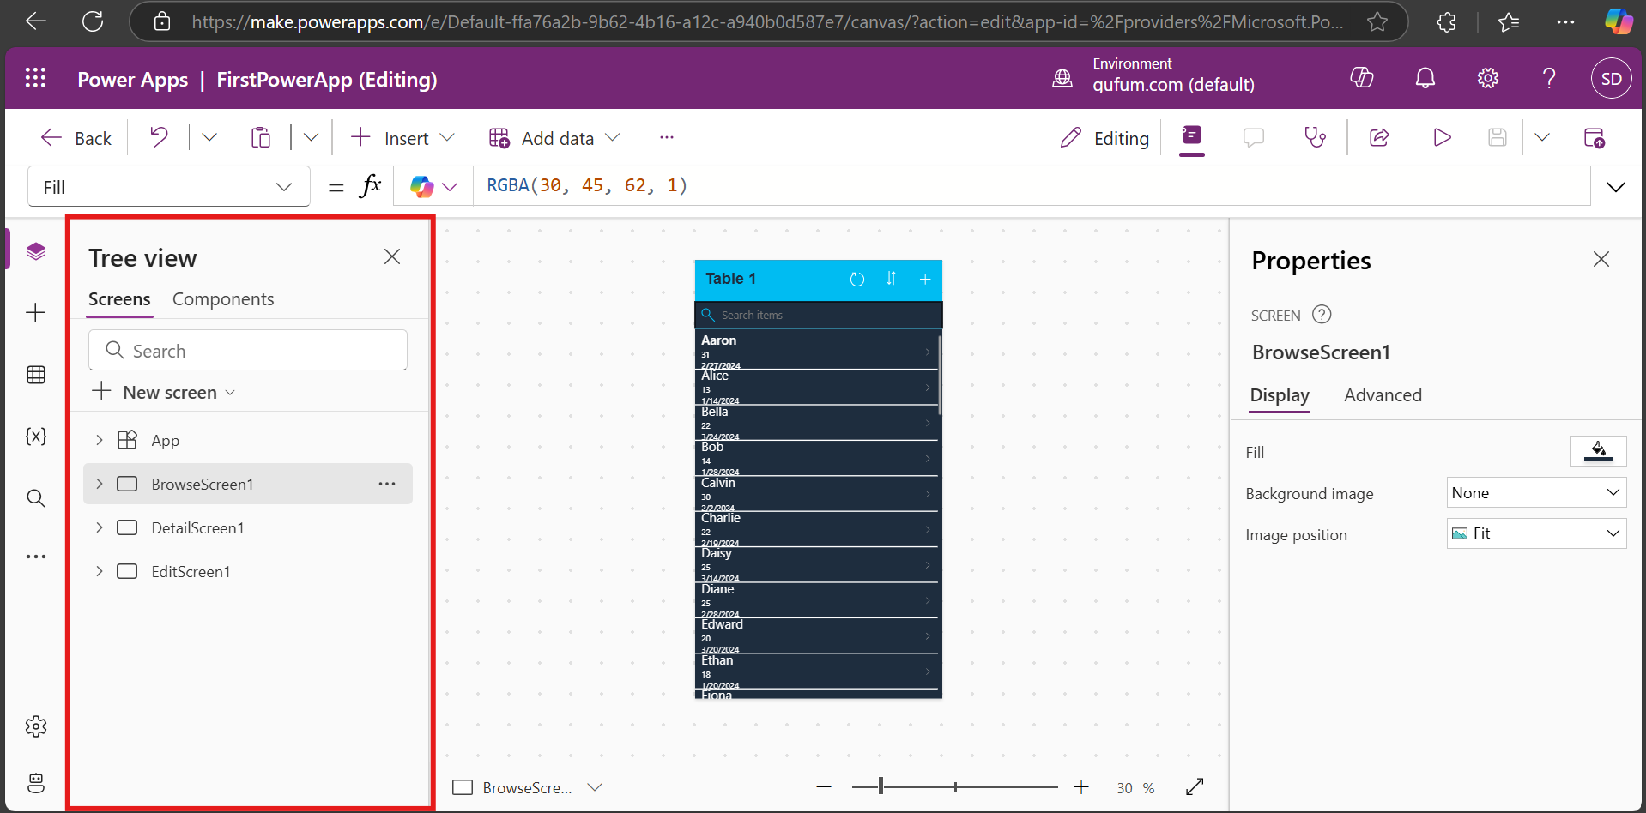

**Browse Screen**:

1. Browse gallery: list of scrollable records.
2. Rectangle: simple rectangle between search and gallery
3. Search icon, textbox, etc actual element of the screen

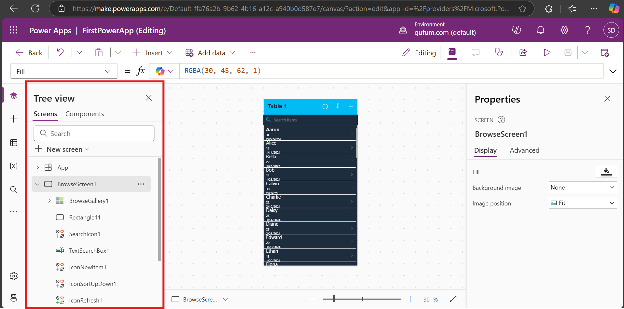

Browse Gallery:

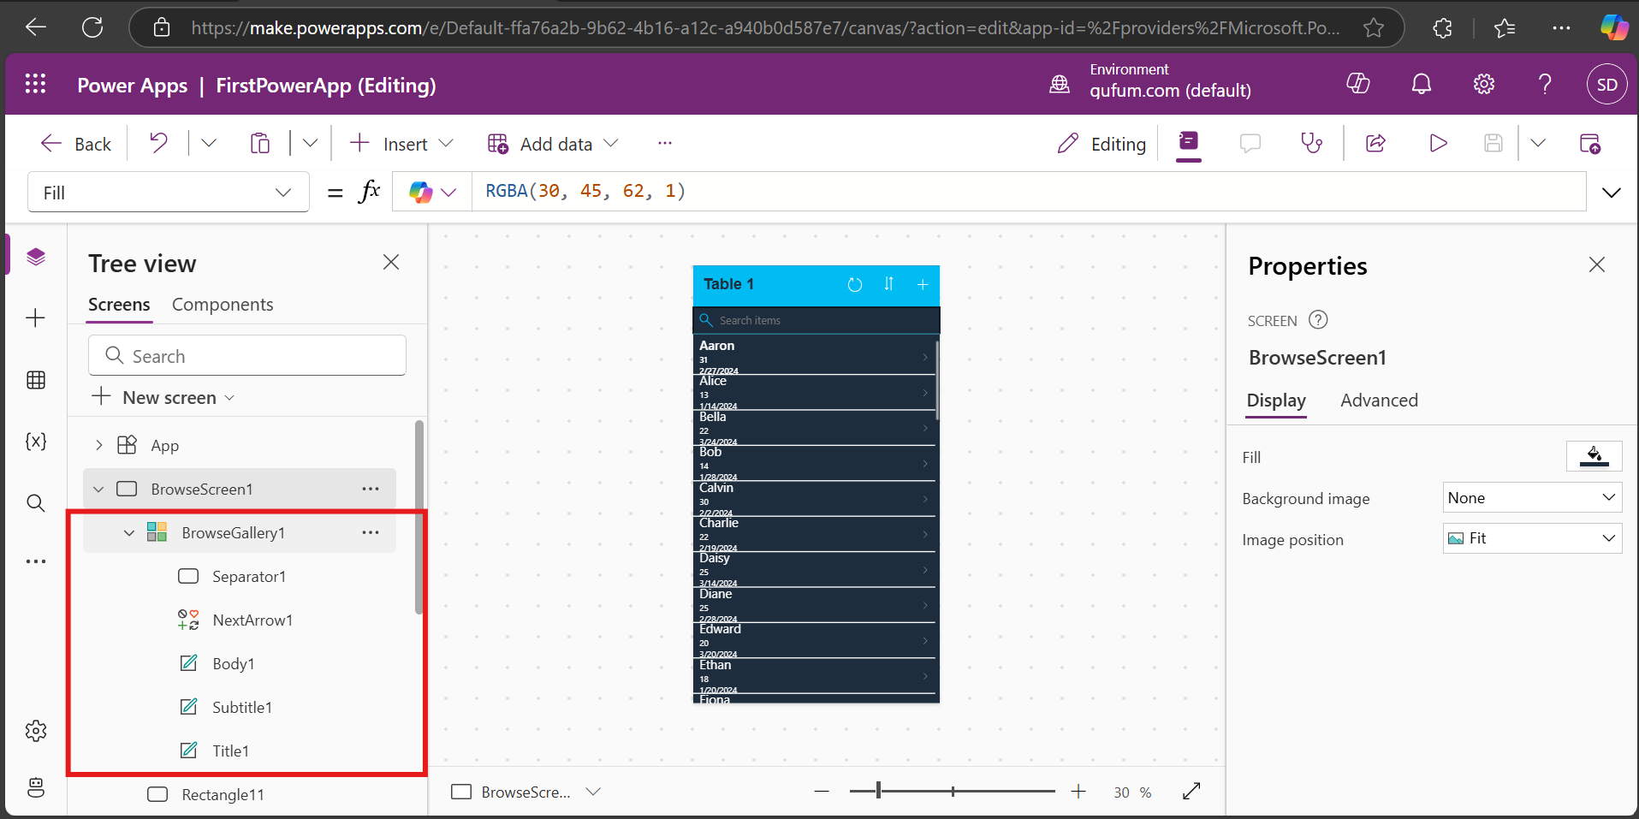

Publish button: To publish app click on publish button

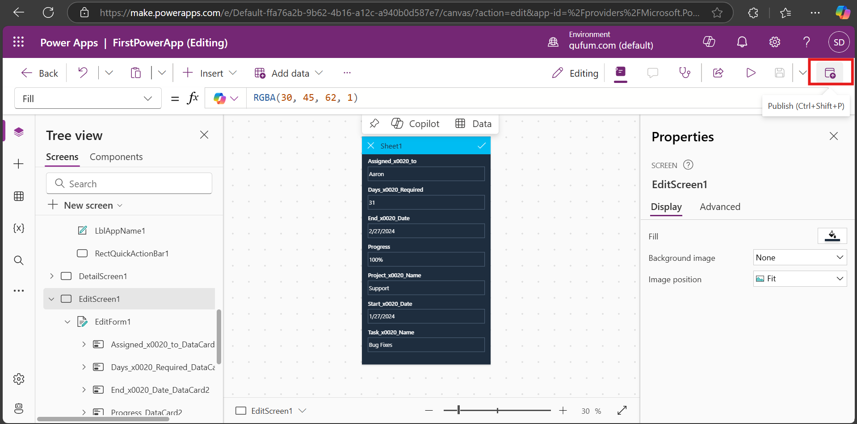

To Change gallery layout

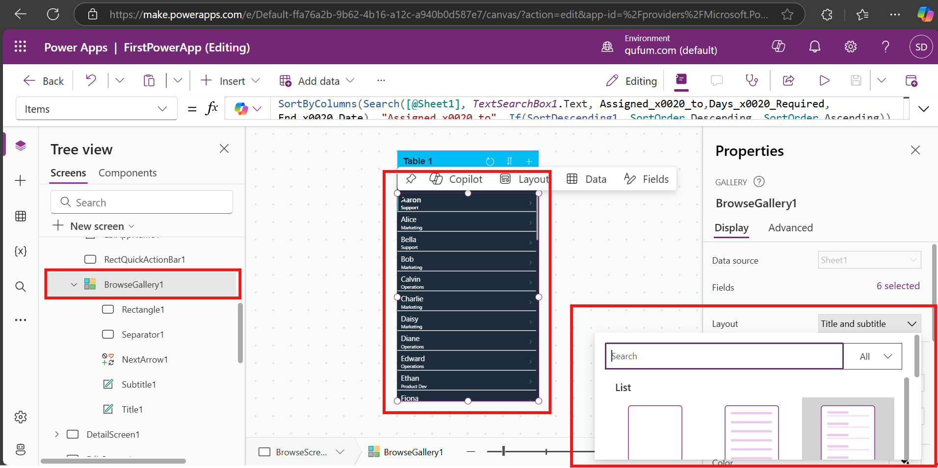

We can add code , javascript also

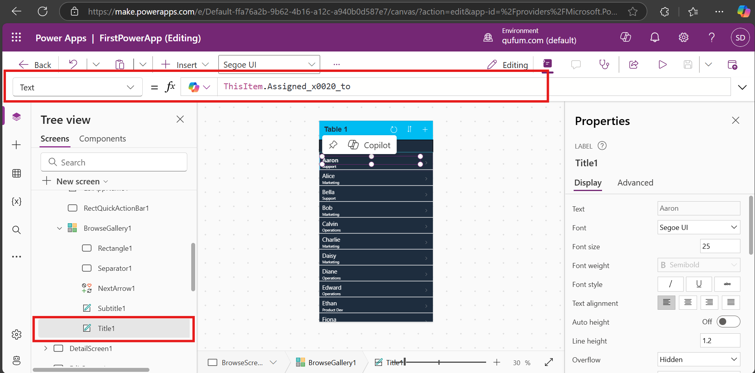

For details screen we have dataCards. Each DataCard have DataCardValue, dataCardKey.

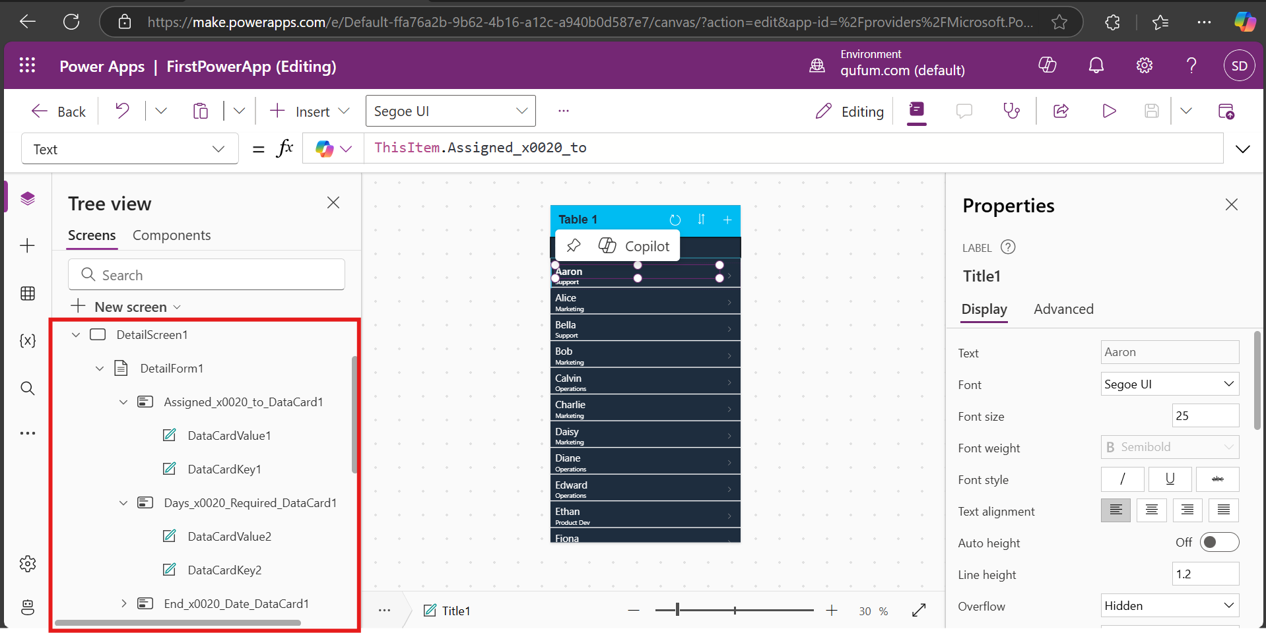

We can rearrange the fields select Details screen-> 7 selected-> it will shows form fields drag to rearrange, add fields.

**Property Assignment**:

Assigning date format: Select Start date DataCard -> unlock it -> check datacardkey Text

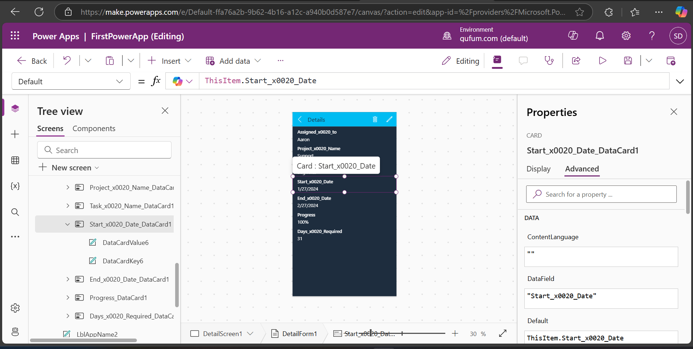

Parent.DisplayName means parent of dataCardKey which is StartDateDataCard

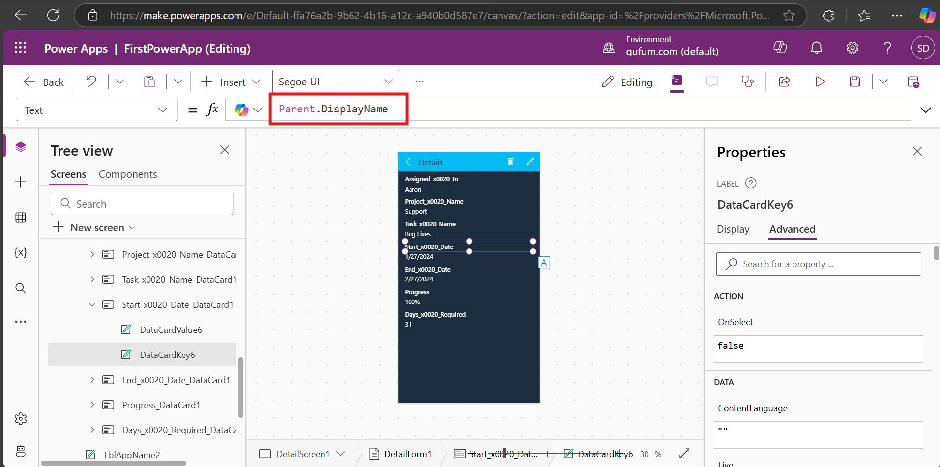

We can write formula/code for that date format.

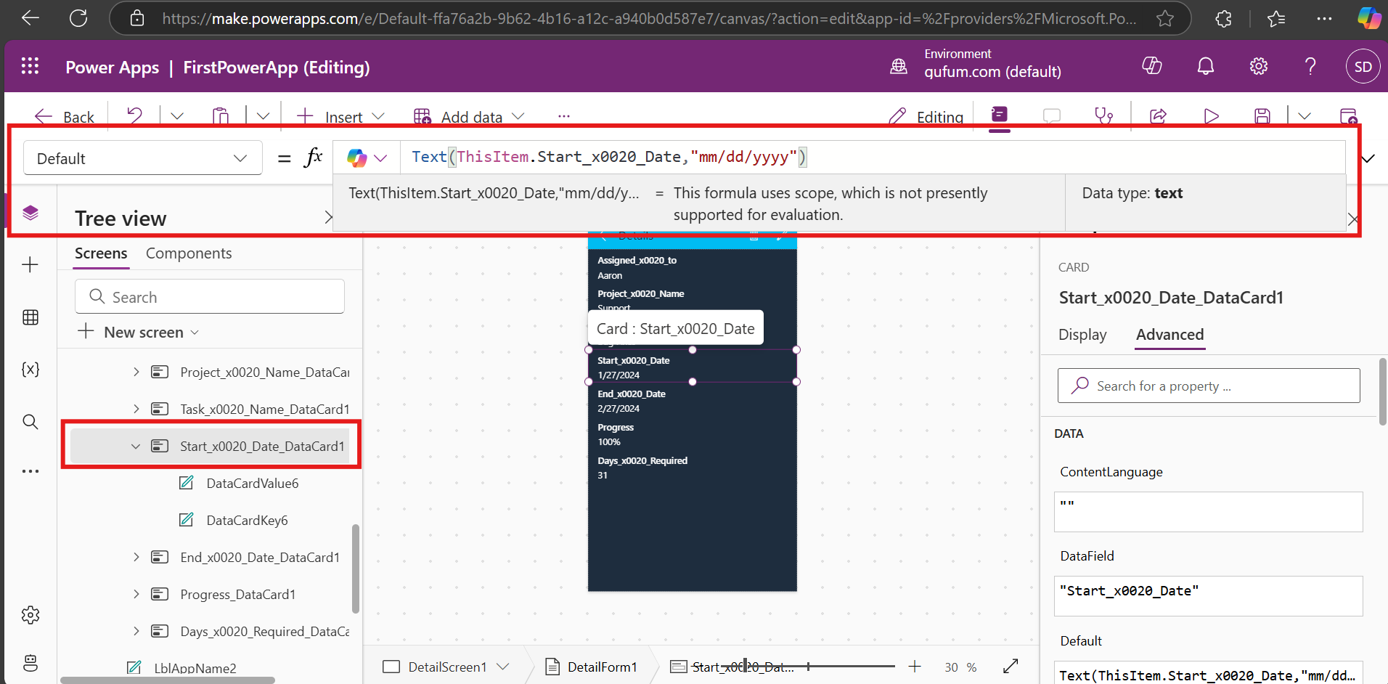

If we want to show name of assigned person on the details screen instead of “Details” then follow below steps:

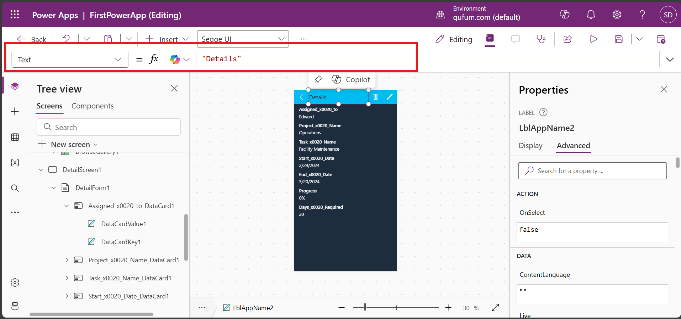

I will add assigned_to name to details screen for that first check assigned to data card name

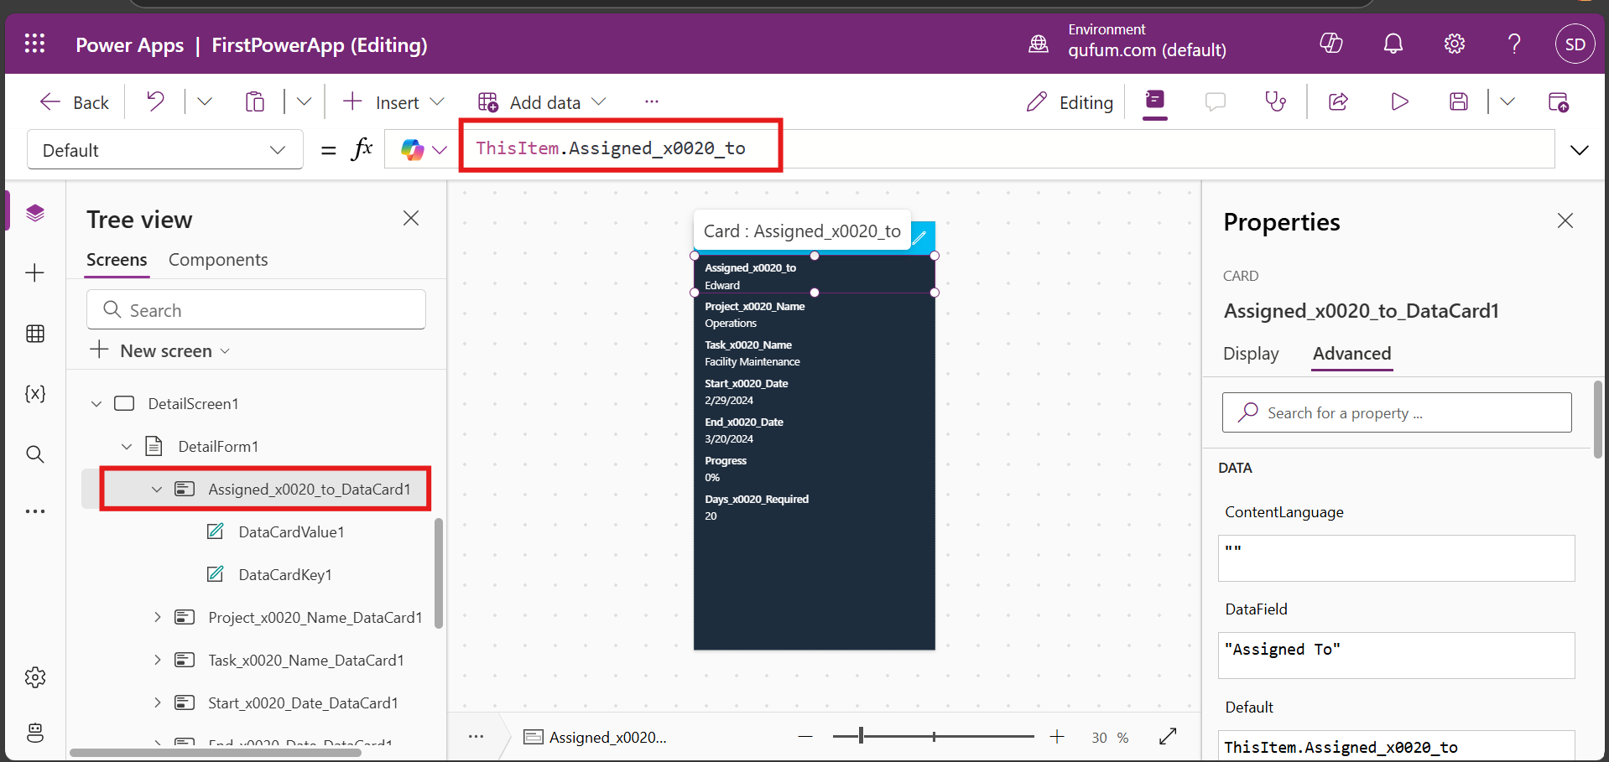

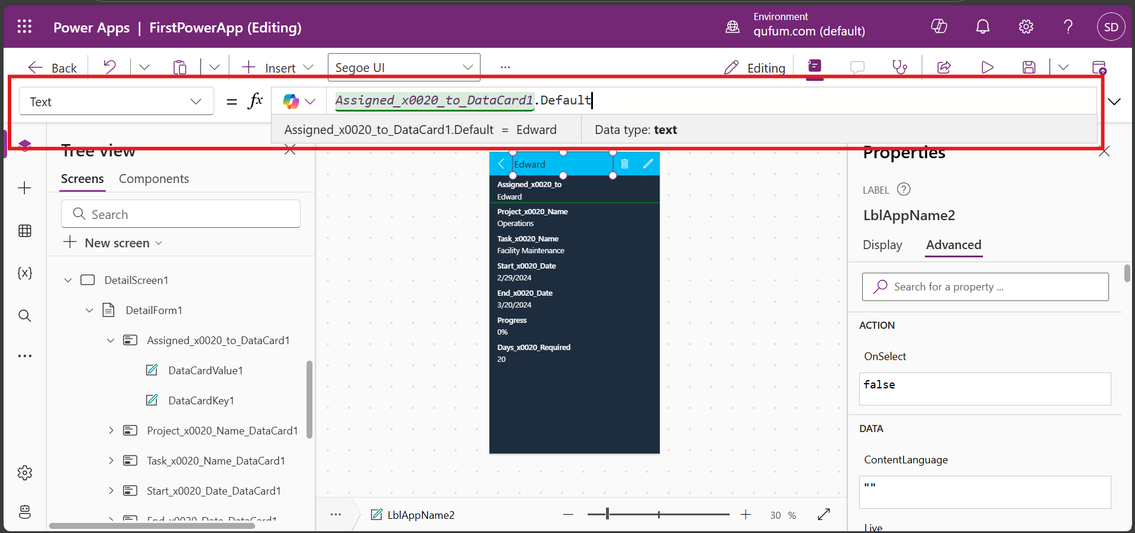

Run the code it will show assigned name to all the details screen Select any data and check particular name is showing or not

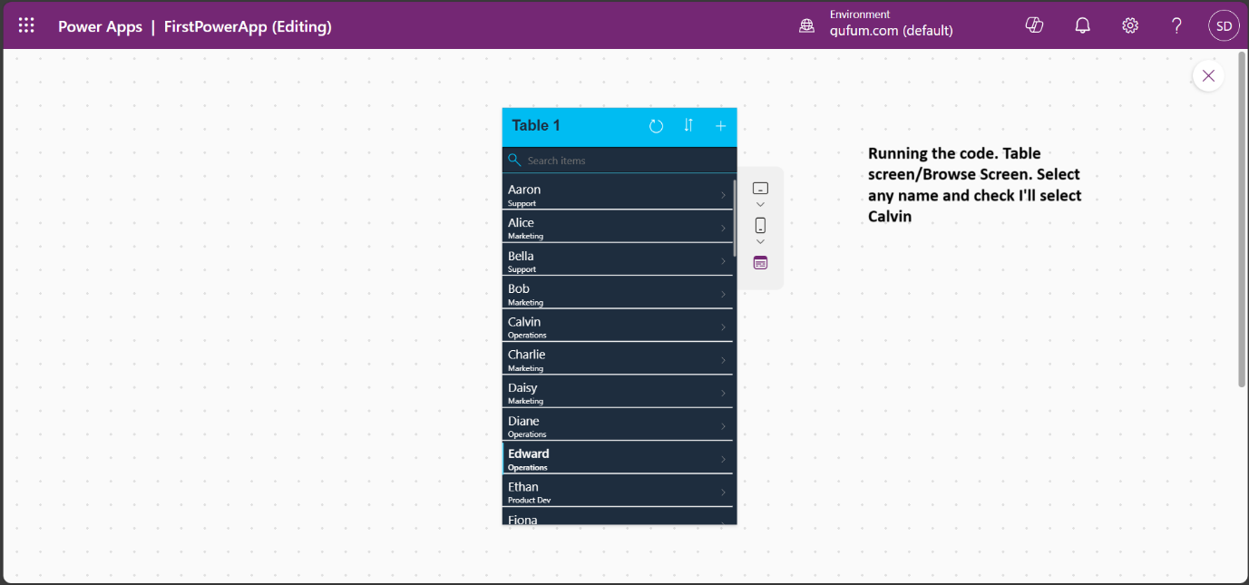

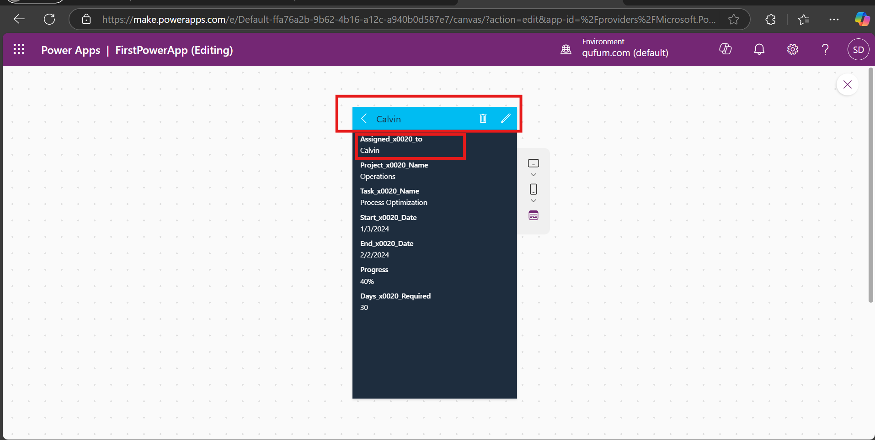

**Edit Screen**: Edit screen have datacard for each field of form

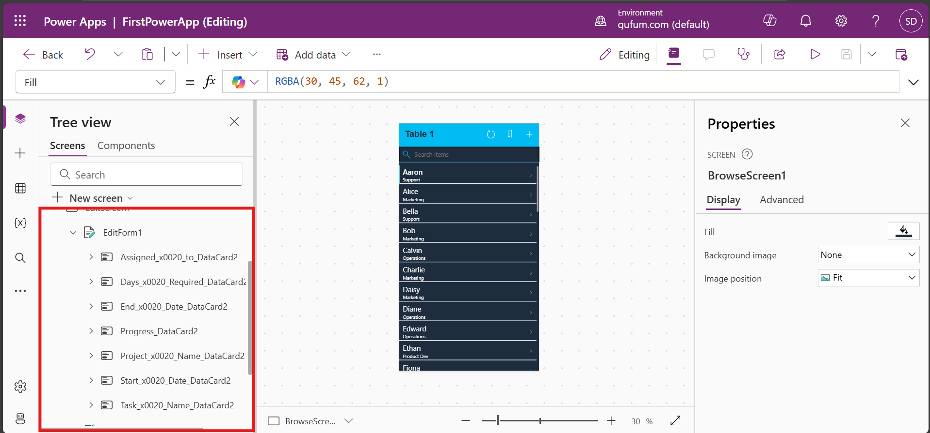

Each Datacard have below element

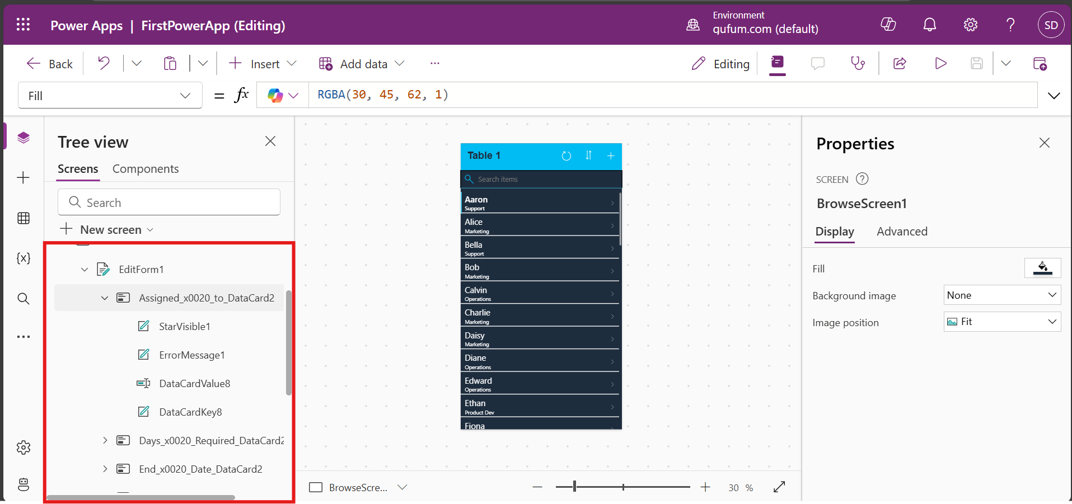

How to put error when user enter wrong input/value. For e.g. in Day reqd field we need digit only what if user enter text/alphabet. So I am going mark this field as view only

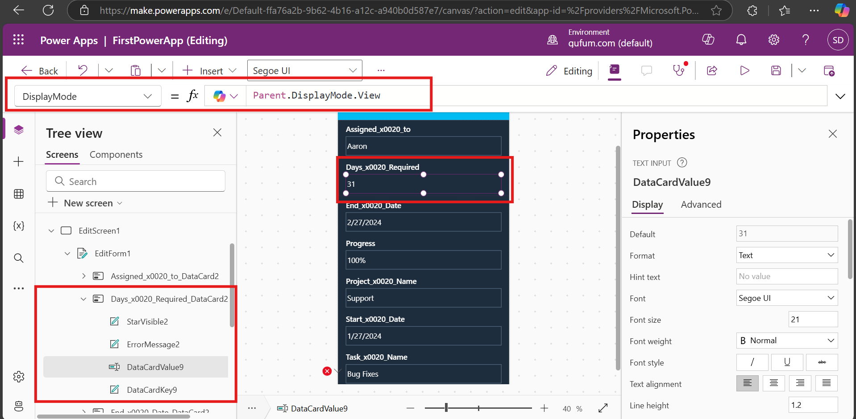

**Triggers**: below onSelect, onChange,onsave etc are called triggers.

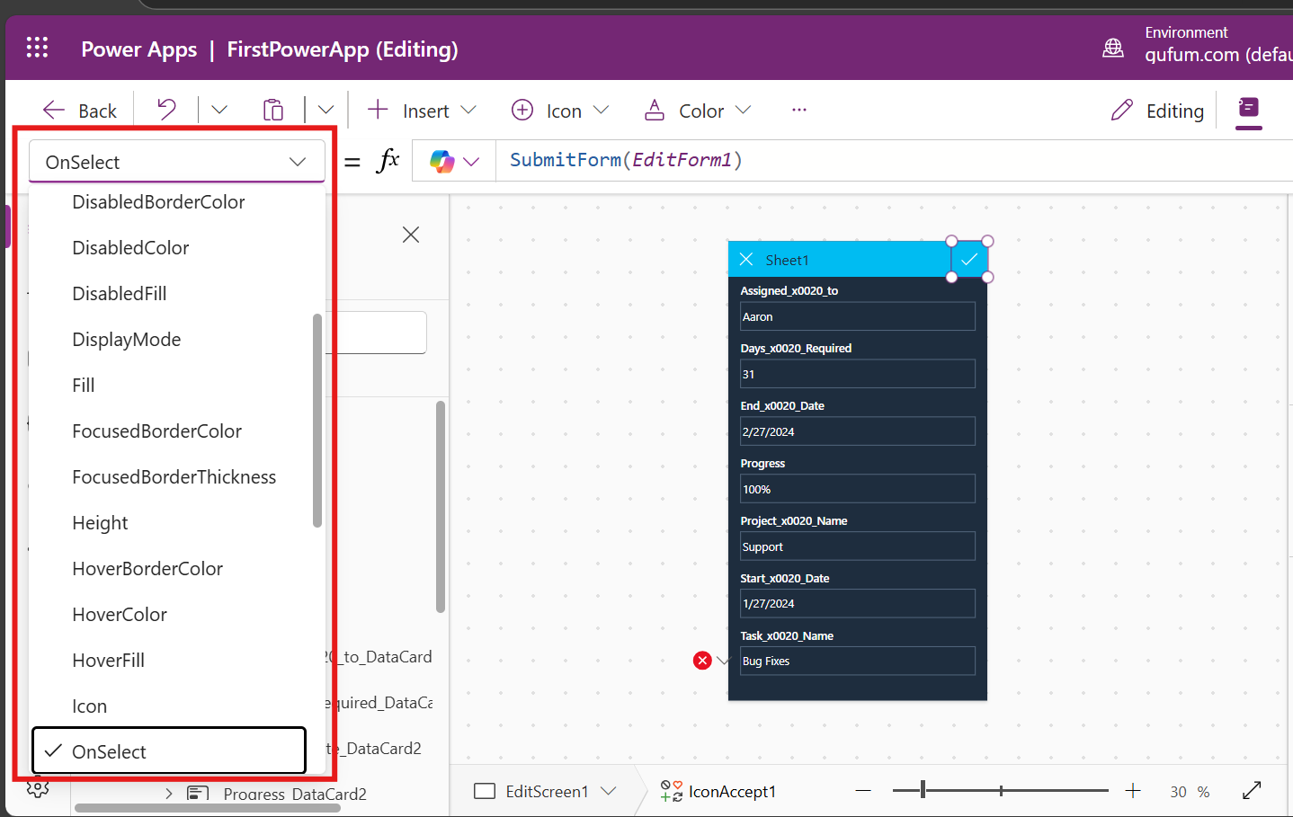

Below formula: explains that it will reset the form name editForm1 and navigates to back to previous screen

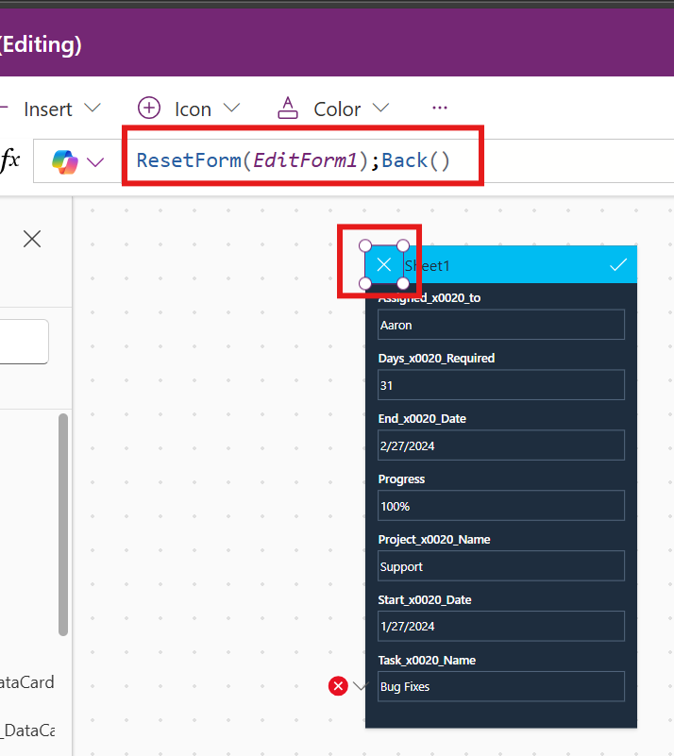

**Functions And Formulas**:

Formulas: [Formula reference - canvas apps - Power Platform | Microsoft Learn](https://learn.microsoft.com/en-us/power-platform/power-fx/formula-reference-canvas-apps)

I have created one formula in that I am concatenating project name and start date and giving space between them. Here for start date role is text that’s why not giving error. If it is number then we need to change number into start e.g. Text(ThisItem.StartDate, ShortDate) like this we can check formula ,syntax and use it in our app.

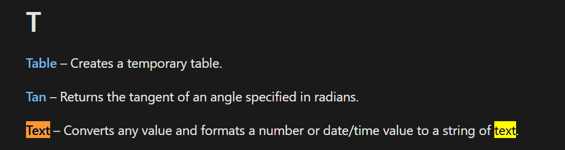 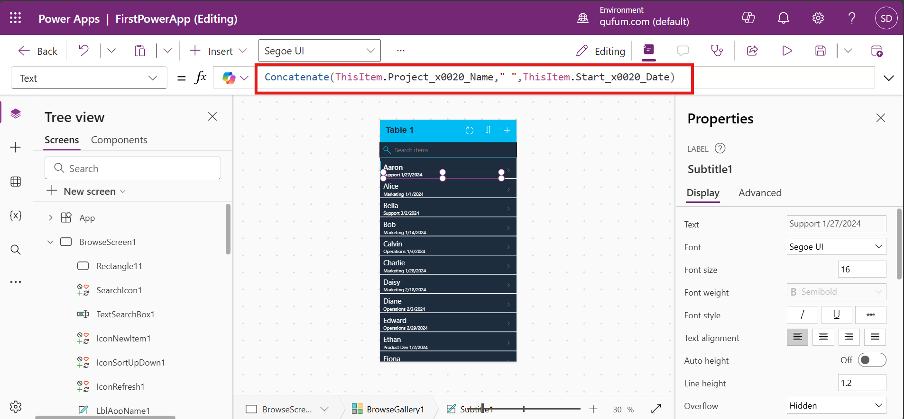

**Introduction to navigation**:

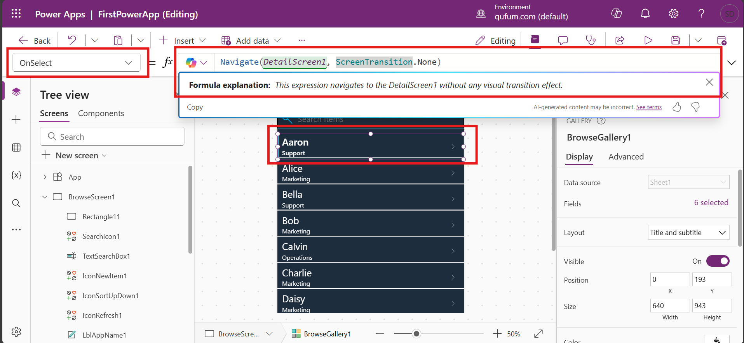

We can use different transition effect for e.g.

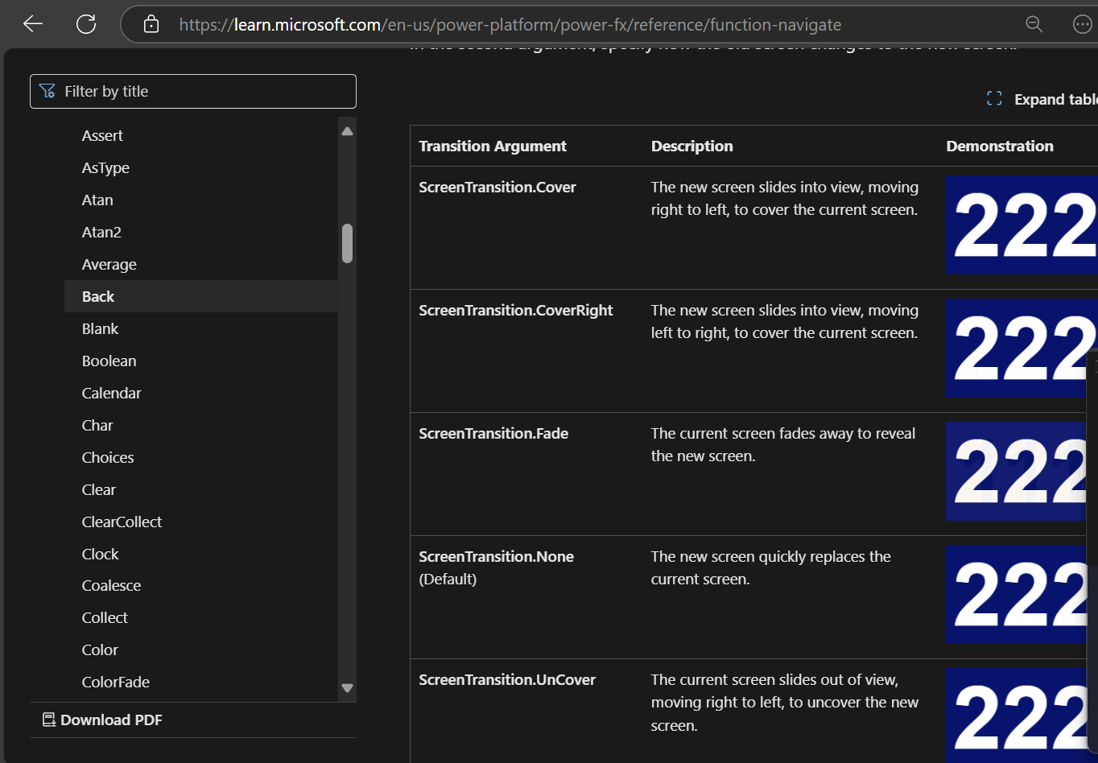

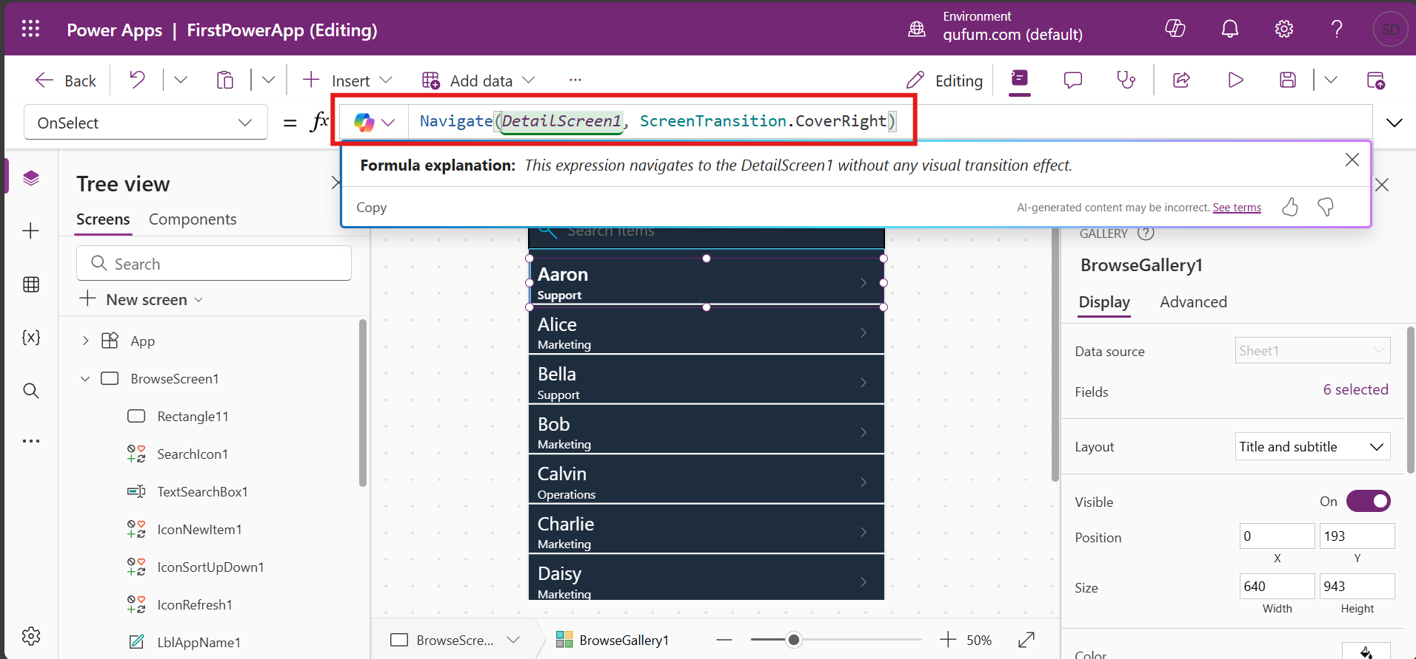

Run preview and check.

If we click on arrow it will show function for onSelect is “Select(Parent)”.

If we check parent of arrow is BrowseGallery1. The function OnSelect will show same formula i.e. “Navigate(*DetailScreen1*, ScreenTransition.CoverRight)“

Now I am adding edit button/functionality on Browsegallery. I want to add edit icon in BrowseGallery so first select BrowseGallery => Insert => Icons=> Edit

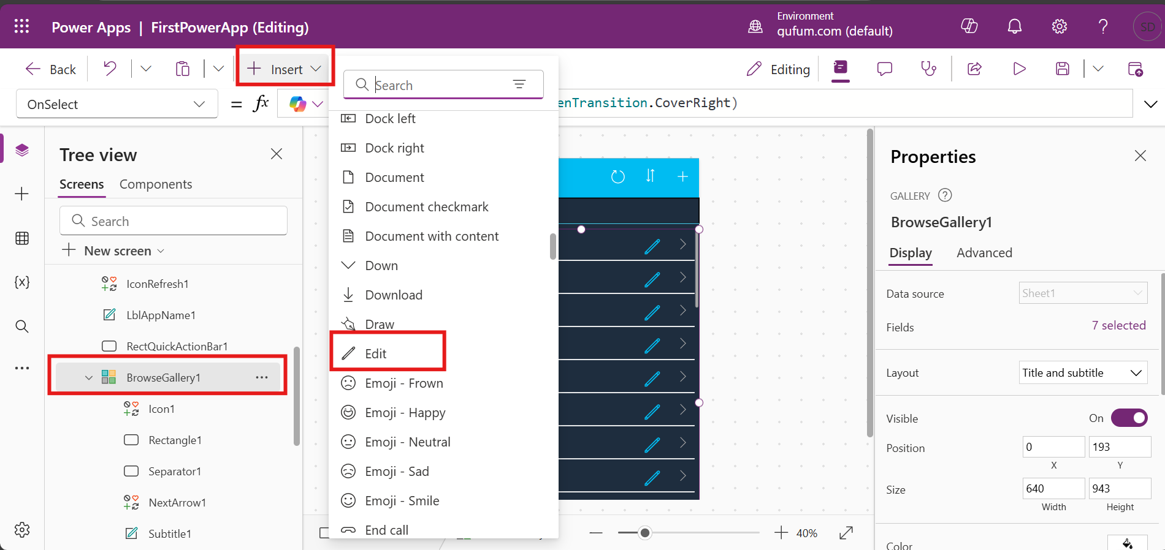

Select icons Drag and set its location, size. Select OnSelect Function and add formula “Navigate(*EditScreen1*,ScreenTransition.Fade)”. So if we click on edit button it will directly navigate to EditScreen with fade transition effect.

The **Back** function returns to the screen that was most recently displayed. Mhnje jar edit button browsegallery(home) varun access kel ani edit screen close keli tr browsegallery la janar karan edit chya adhi ti screen use keleli. Jar edit button Details screen varun access kel tr edit screen open hoil. Jar edit screen close keli tr Details screen la janar karan last use keleli detailscreen hoti.

**Error Checking**:

Using AppChecker also we can check errors

